**[USB Adapter] What should I do if I can't use the adapter after installing the driver on Windows 7?**

This FAQ applies to Tenda’s USB adapter device.

**Problem description**: An error pops up after installing the adapter driver on Windows 7.

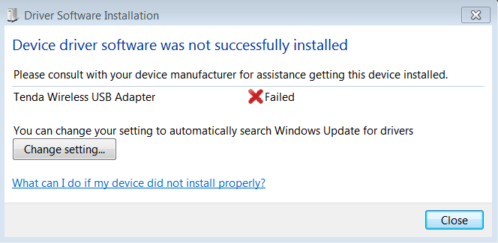

**Solution:**

**Step 1**: Uninstall Other Adapter Drivers

Please open Control Panel.

Then, enter Uninstall a Program to check whether other adapter drivers are installed.

If so, please uninstall other drivers.

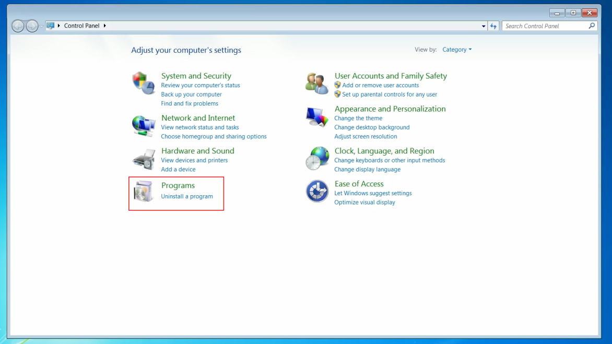

**Step 2**: Check Device Manager

Please open Computer, click System properties.

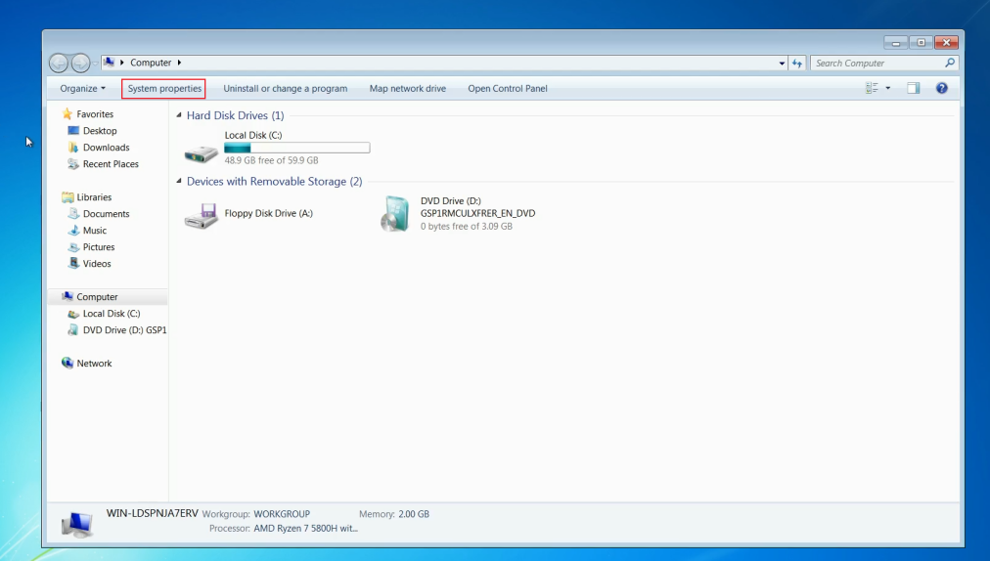

Then, click Device Manager.

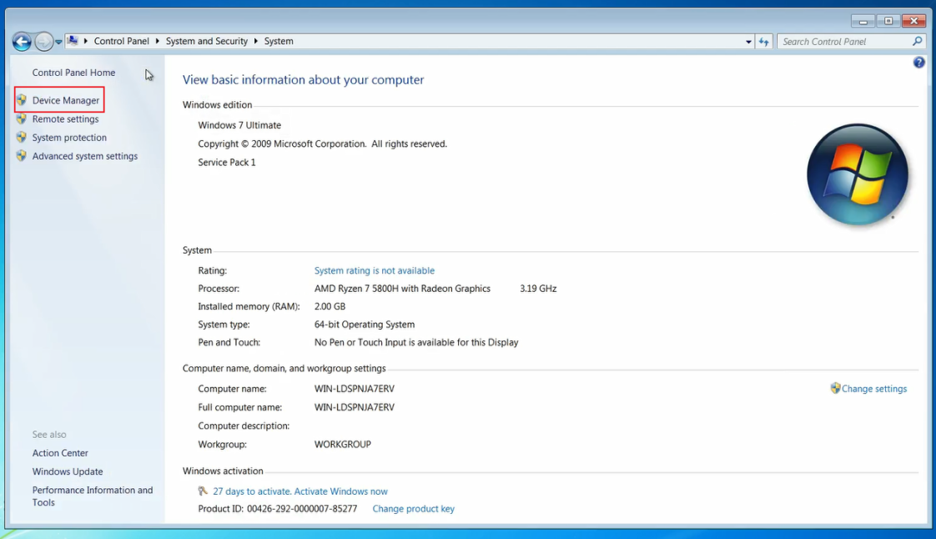

Find Network adapters. Right click "Tenda wireless USB adpter", then click properties.

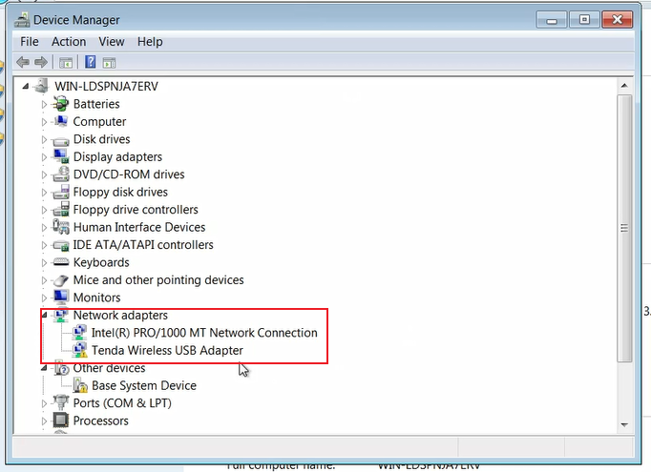

At last, please read the device status.

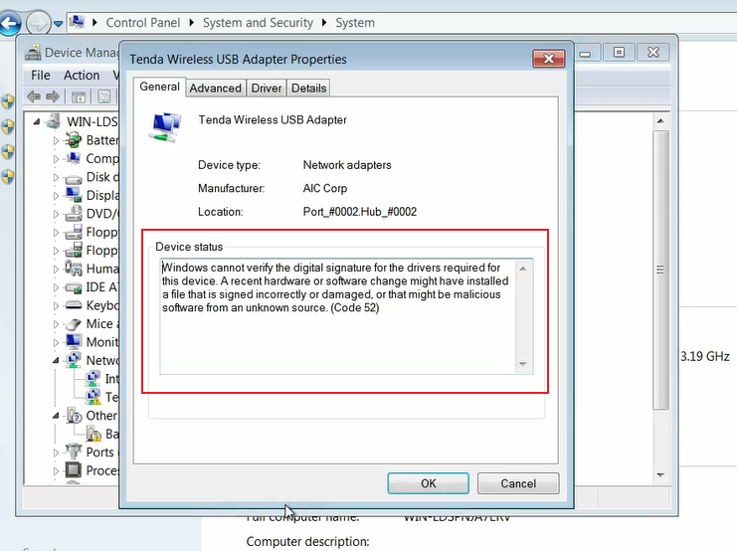

If the device status contains Code 37:

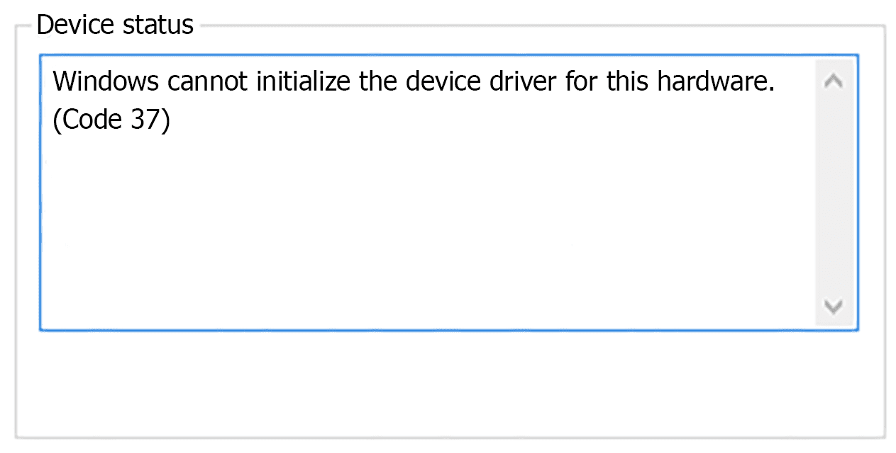

Please visit this website to download the patch.

Patch Download Link: <https://www.catalog.update.microsoft.com/Search.aspx?q=KB2685811>

After installing the patch, please restart your computer.

(Caution: x86 means 32-bit, x64 means 64-bit. Please download the patch according to your own computer operating system.)

If the device status contains Code 52:

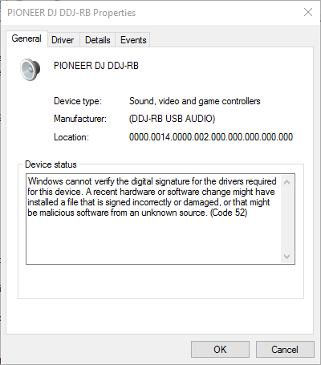

Please visit these websites to download the patch.

Patch Download Link:

1. bit: <https://www.microsoft.com/en-us/download/details.aspx?id=46078>

64-bit: <https://www.microsoft.com/en-us/download/details.aspx?id=46148>

After installing the patch, please restart your computer.

If the above steps still do not solve your problem, Please contact our technical support.