**[How to limit the speed of devices connected to the network?](https://www.tp-link.com/us/support/faq/3299/)**

The article tells the way to limit speed on the devices via **the Speed Limit**(Bandwidth Control) feature on the Tenda router.

Network Topology of Tenda Routers outlines the device connectivity of your network visually and helps you manage the network easily.

**To limit the speed of a connected device:**

1. Enter **http://tendawifi.com**, and log in with the password you set for the router.
2. View the **Network Topology** and click on the **Controller** icon .
3. Click **Clients** to view the client devices in your network. The figure below shows MX12 ’s router Web UI page as an example.

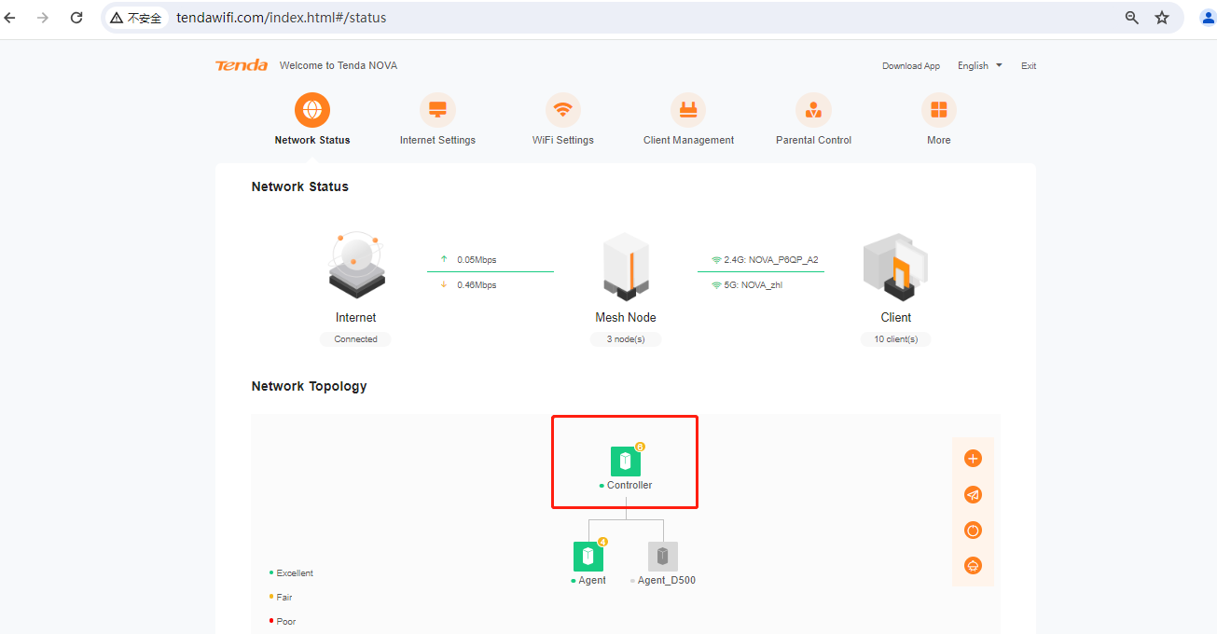

1. Find the device you want to limit the speed, there are Upload speed and Download speed, then click the drop-down option .
2. You can select the speed you prefer. (128 or 256KB/s or Unlimited, the default speed is Unlimited)

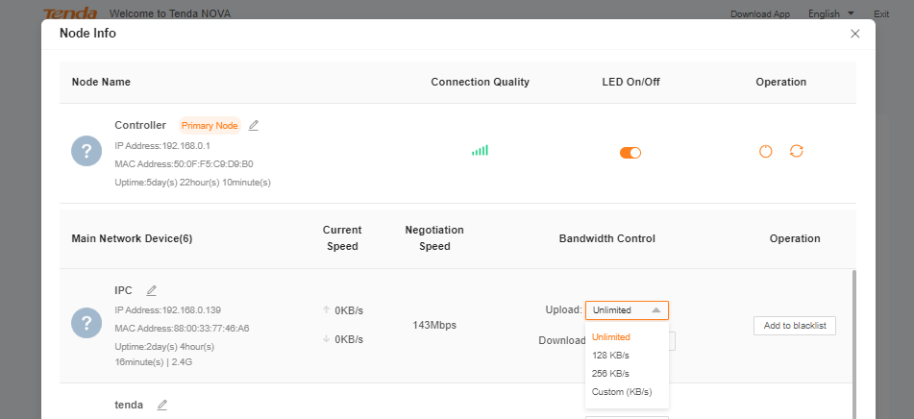

1. You can also customize the speed you want. (Number ranging from 1 to 256000) and set the download and upload speed limit according to your needs.

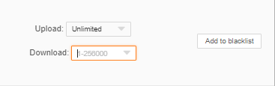

1. It will save successfully once you set the settings. Now the speeds of the device will be limited.

