**How to configurate client mode for CPE**

Note :Please make sure your PC connect with CPE in the network.

Step1：we should modify to the same network segment between CPE and PC. Click WLAN and go to **properties>Internet Protocol Version 4** TCP**/IPv4，**change to **Use the following IP address。**Enter IP address 192.168.2.X, and Subnet mask :255.255.255.0. Save.

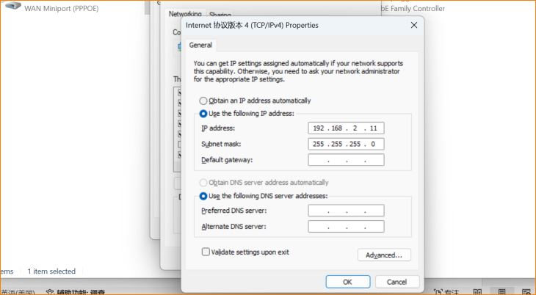

Step2：Access to www.tendacn.com.You can find CPE Management in the product. Download to your PC,and install CPE assistant and open it.

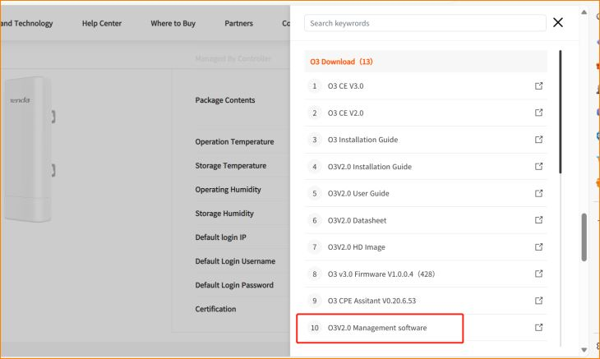

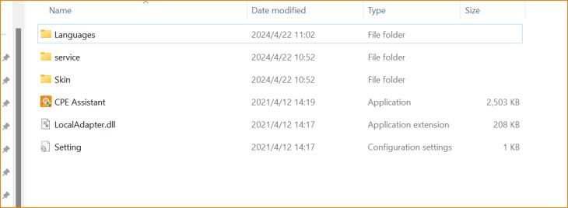

Step3： we can search CPE in LAN.When we click“Search“it will show the CPE status.Check its info Change the IP of CPE.We can manage the CPE by this tool.

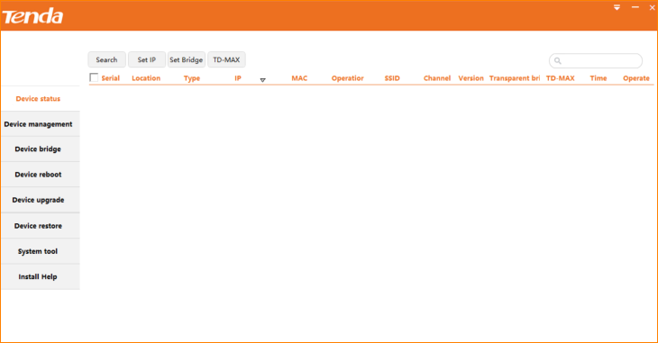

Step4： you can configuration the CPE in the Device management.You can change its SSID、Wireless power and Wirelss channel so on.

