**How to enable Remote Web Management for IP-COM router**

Step1：Enter ip address ：192.168.0.252. enter the router login interface in the browser, with the default password : admin

Note :Please make sure your PC connect with router in the LAN.

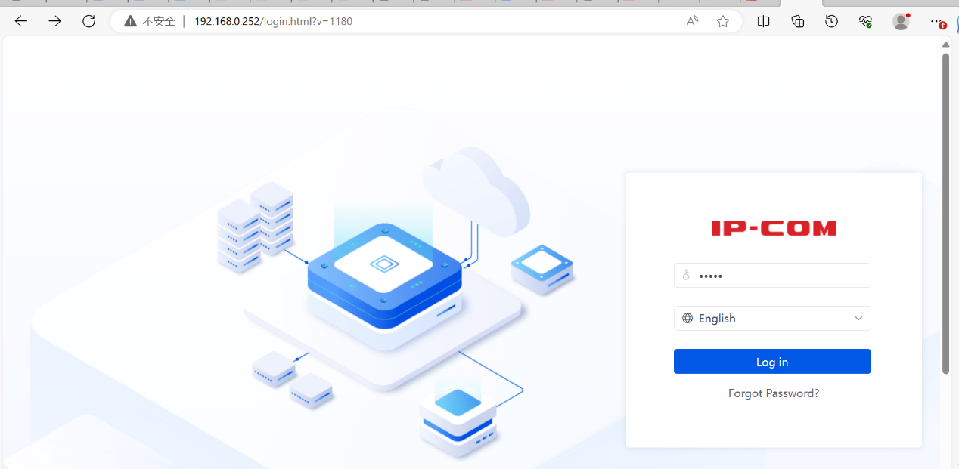

Step2:**more**>>**maintenance services** >>**remote web management**..Open Remote Web Management

Tips：if you canot access this ip address ,you can reset the router

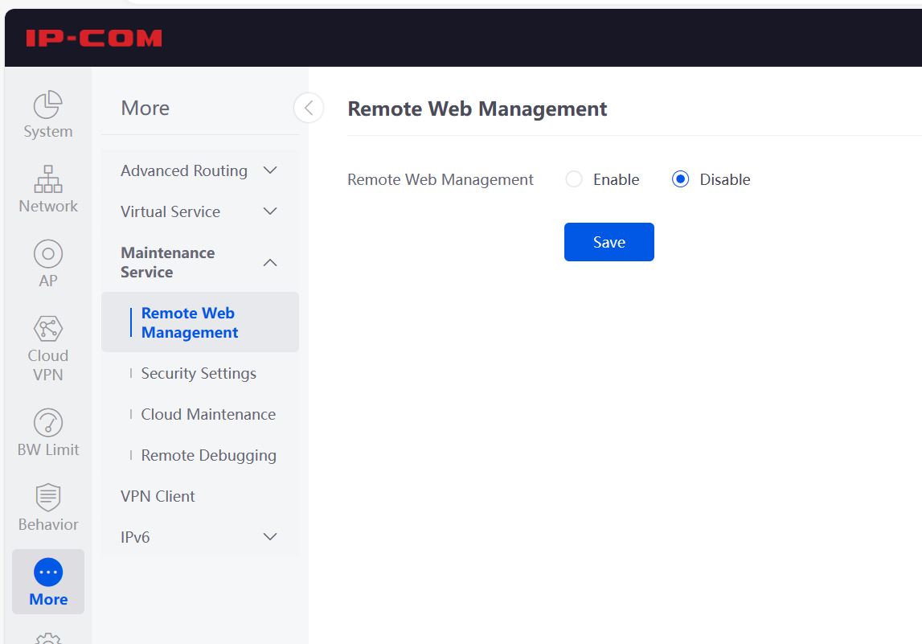Step3:Open remote web management, select wan port which you connect, you can copy your remote IP address to save

Note：you can save this ip address for remote management

