**How to configurate client mode for CPE**

Note :Please make sure your PC connect with CPE in the network.

Step1：we should modify to the same network segment between CPE and PC. Click WLAN and go to **properties>Internet Protocol Version 4** TCP**/IPv4，**change to **Use the following IP address。**Enter IP address 192.168.2.X, and Subnet mask :255.255.255.0. Save.

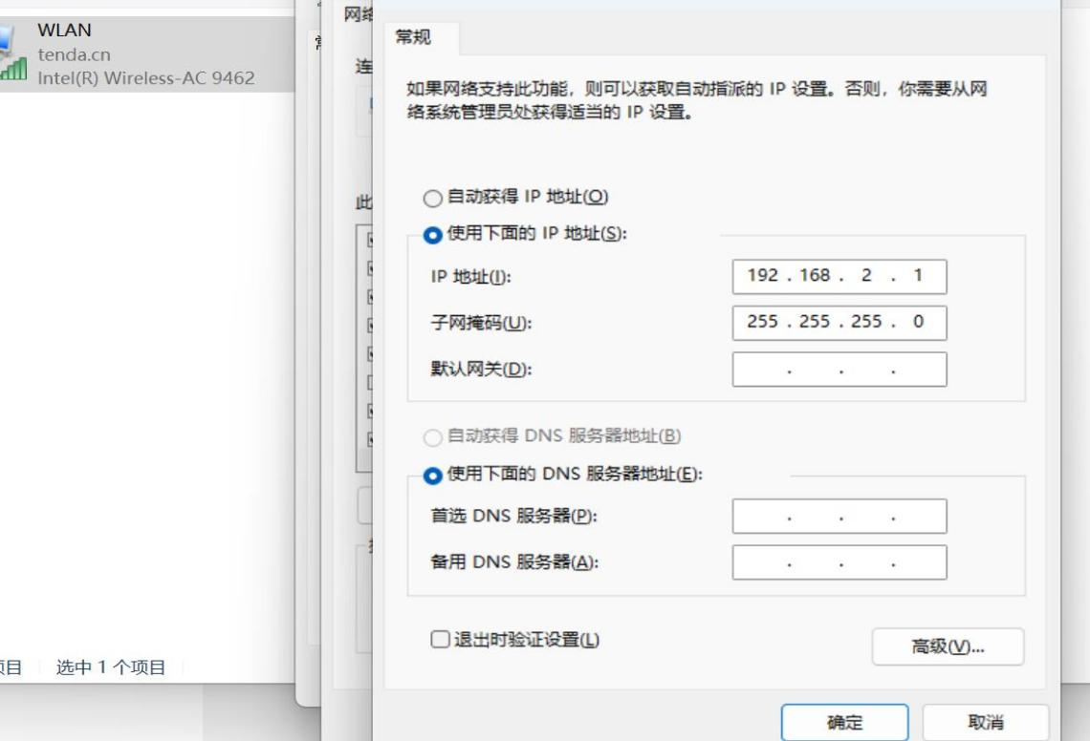

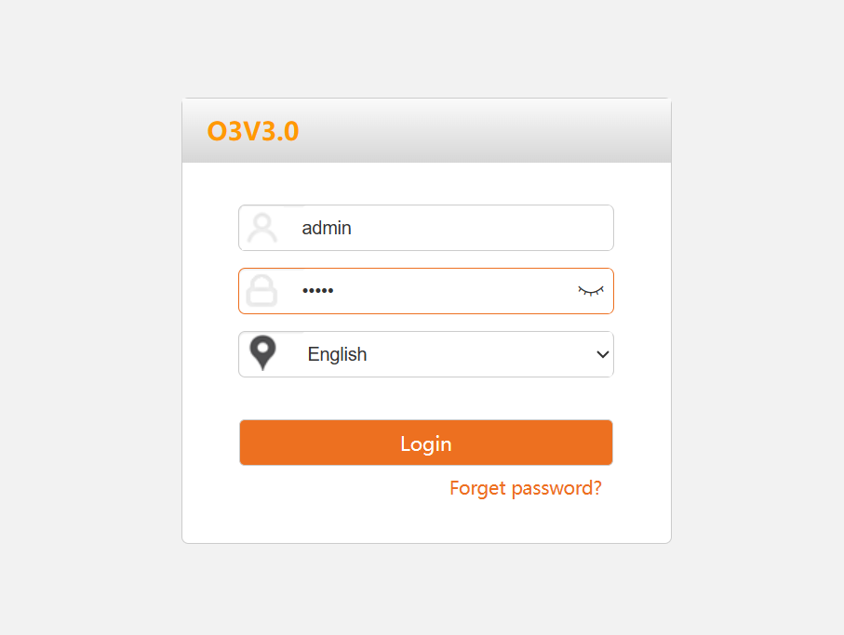

**Tip:** if your cannot log on the web,please reset your CPE

Step2：Select Client mode in Quick Settings, click next step

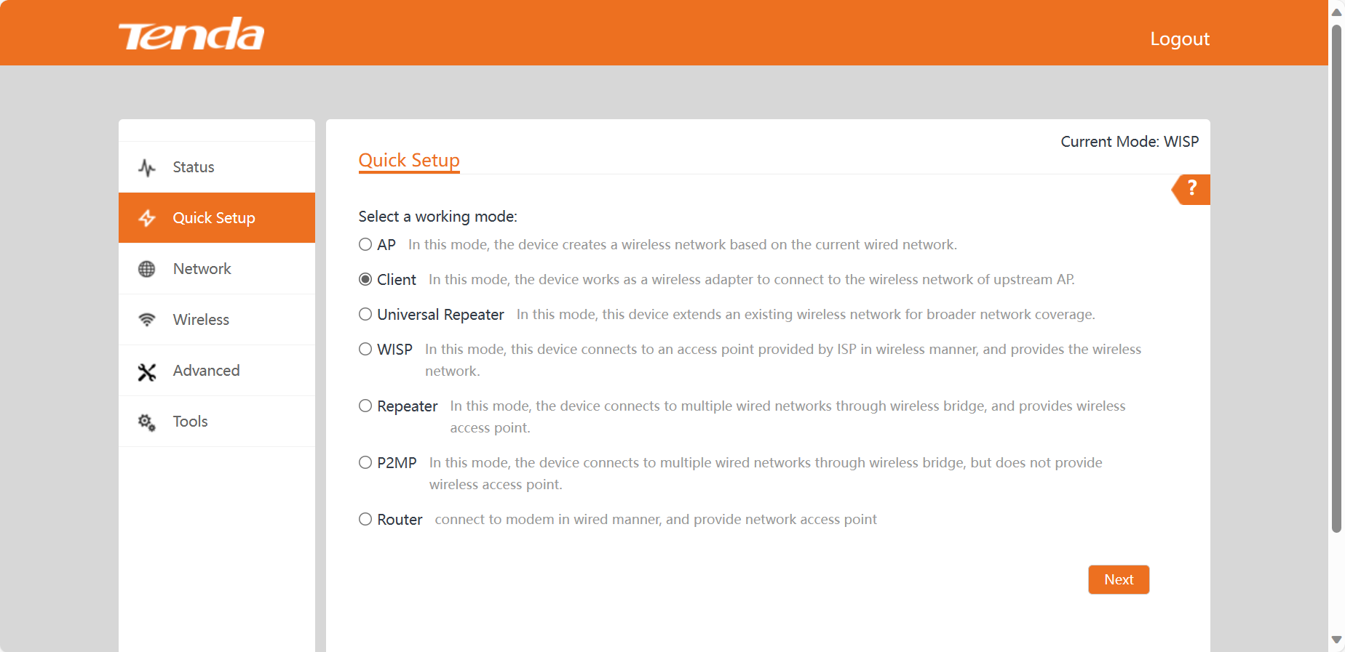

Step3： Click "Scan", and select the wireless network you want to connect,enter the password.

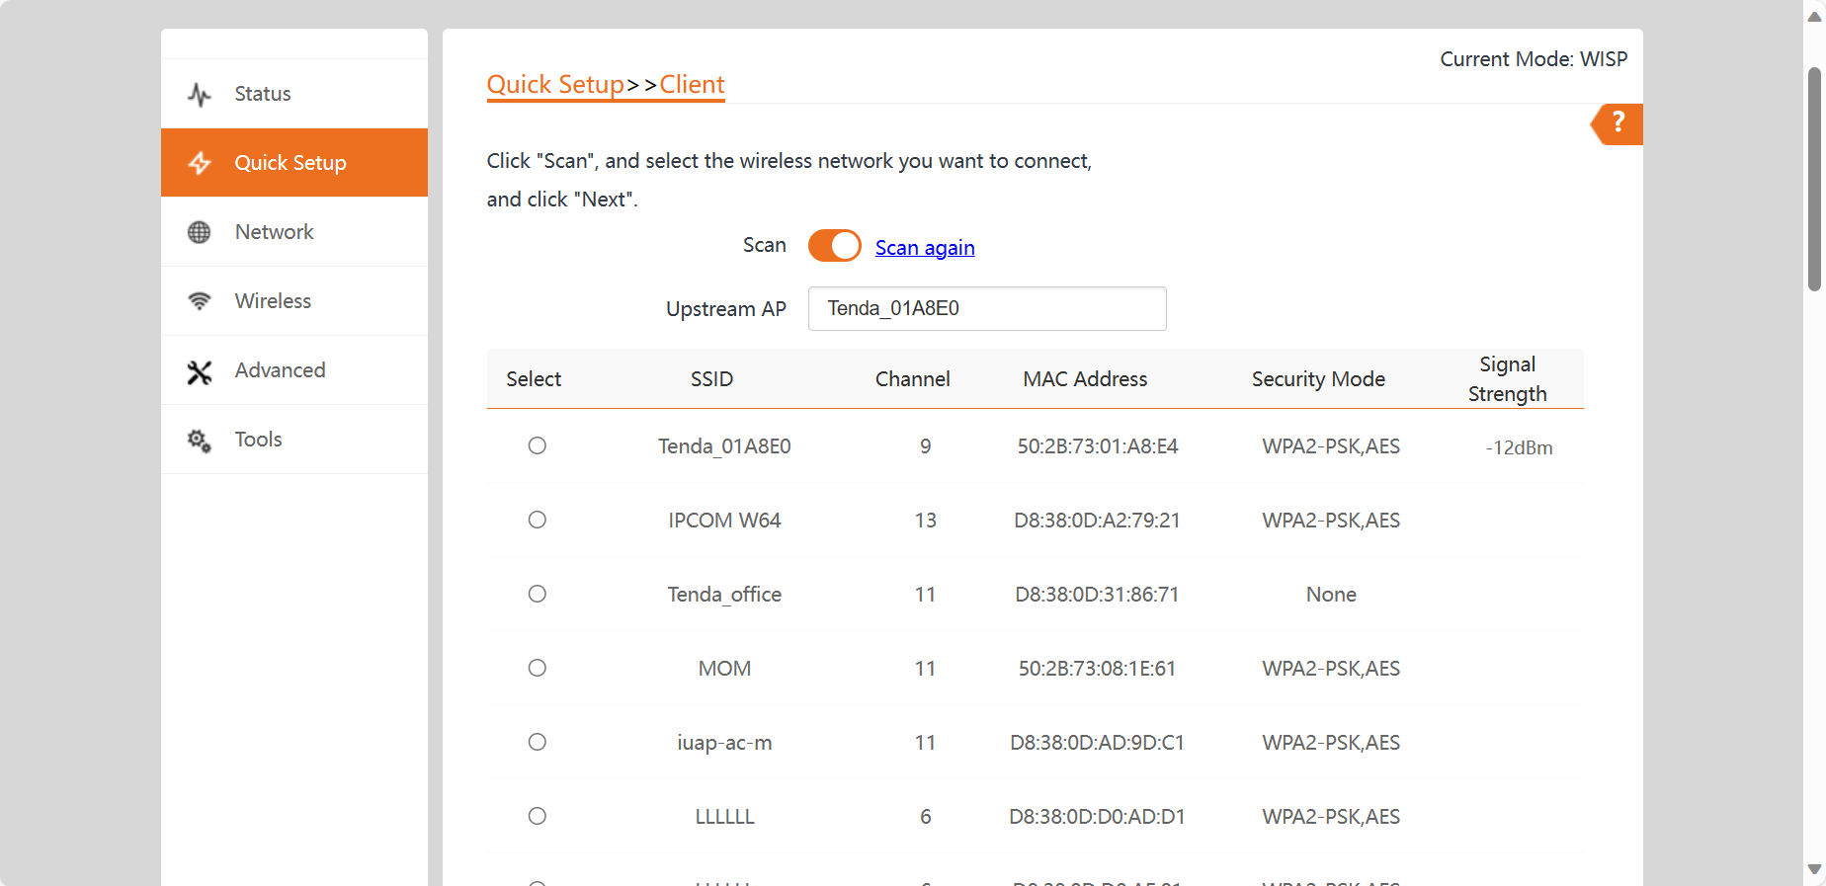

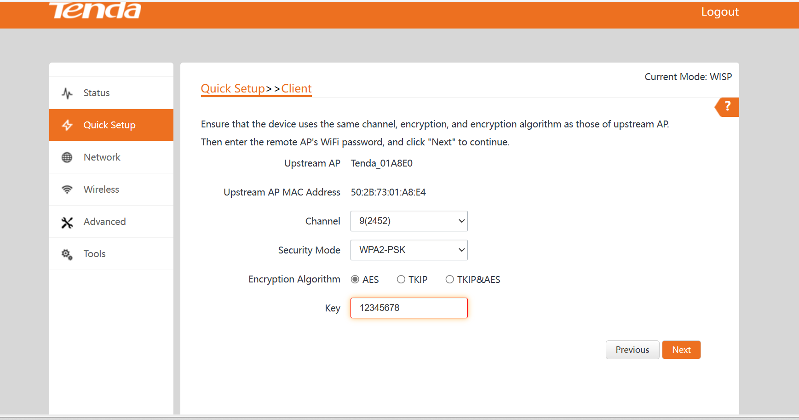

Step4： Set the IP address to an unused IP address belonging to the network segment of upstream AP. Click Next.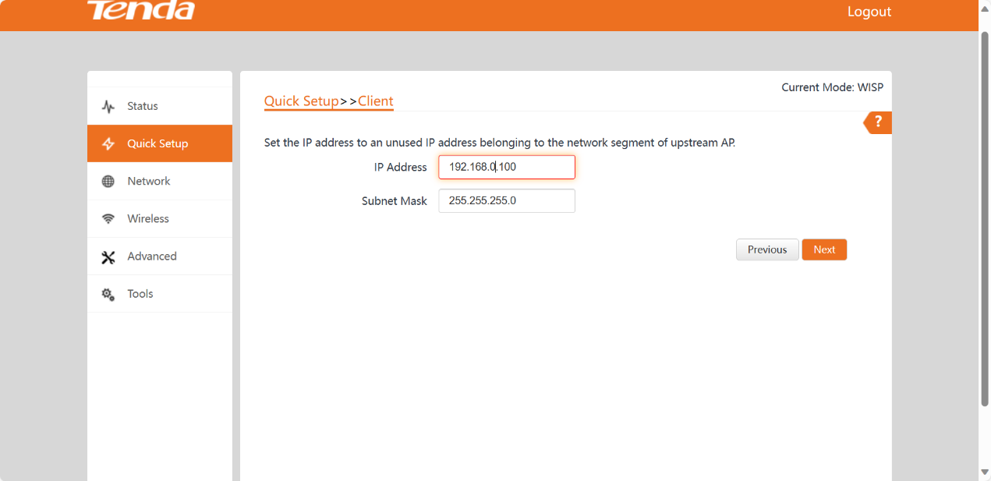

Step4： Save and apply this setting

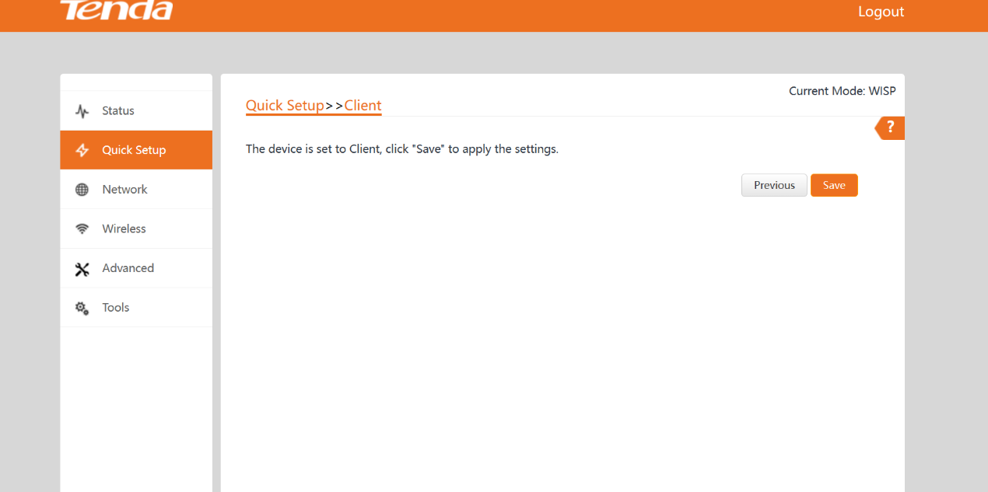

Step5：Successfully applied after device restart

