**How to configurate client mode for CPE**

Note :Please make sure your PC connect with CPE in the network.

Step1：we should modify to the same network segment between CPE and PC. Click WLAN and go to **properties>Internet Protocol Version 4** TCP**/IPv4，**change to **Use the following IP address。**Enter IP address 192.168.2.X, and Subnet mask :255.255.255.0. Save.

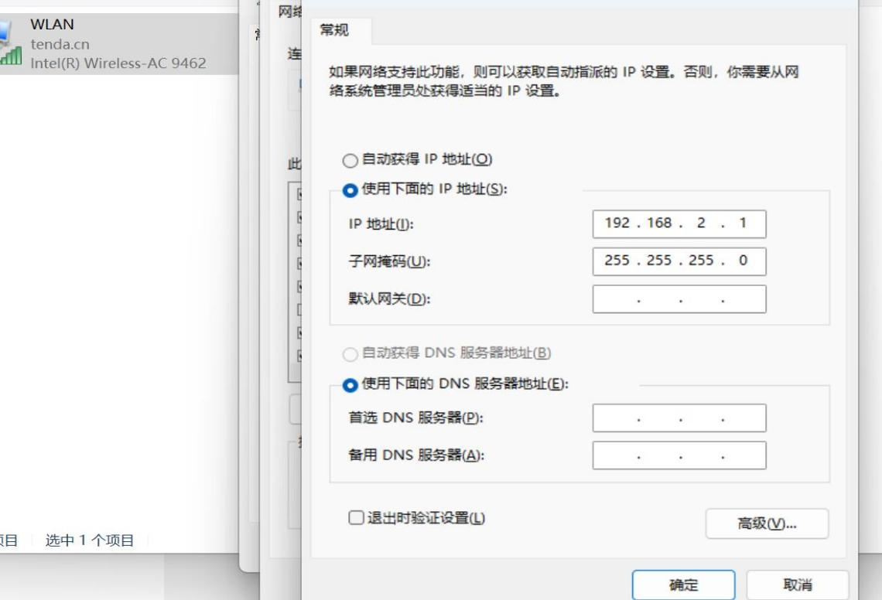

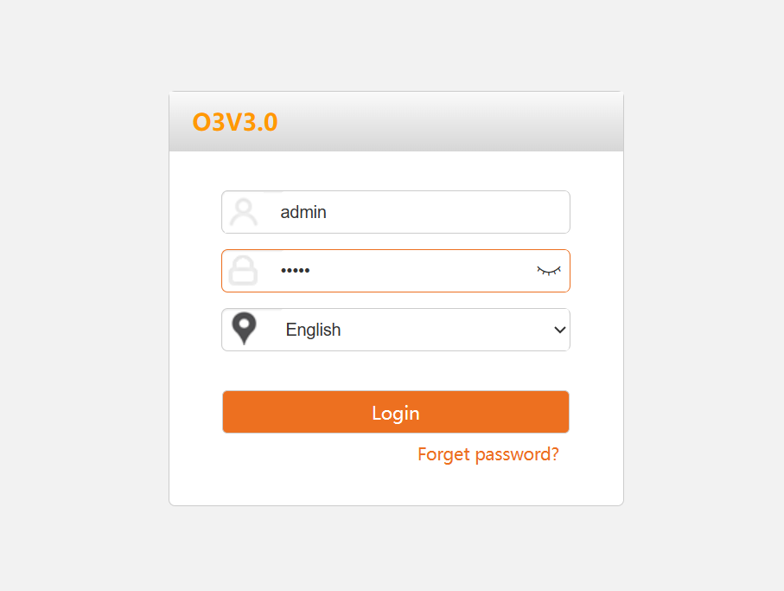

**Tip:** if your cannot log on the web,please reset your CPE

Step2：Click **Wireless**>>**Access Control** .it will show the SSID of CPE,and we can modify the Mode Disallow or Allow.can add online devices .

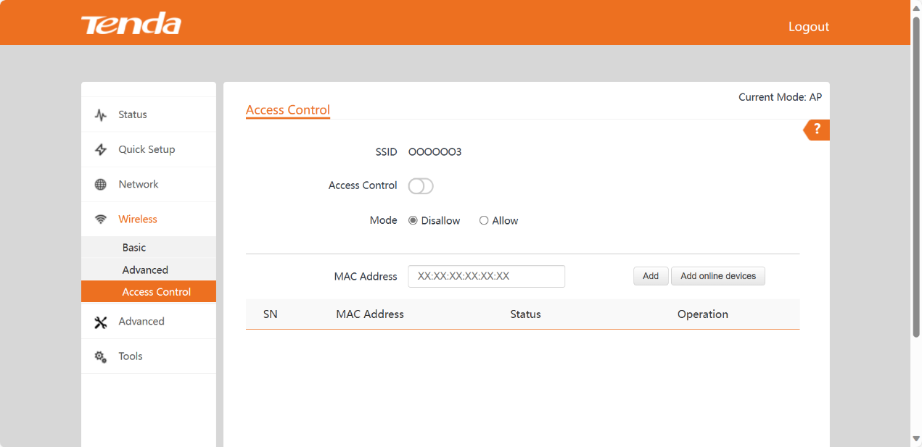

Step3： Click "Add online devices ", it will show all of the terminer,its IP Address and MAC Address,pick the device you want to add.Click Add.

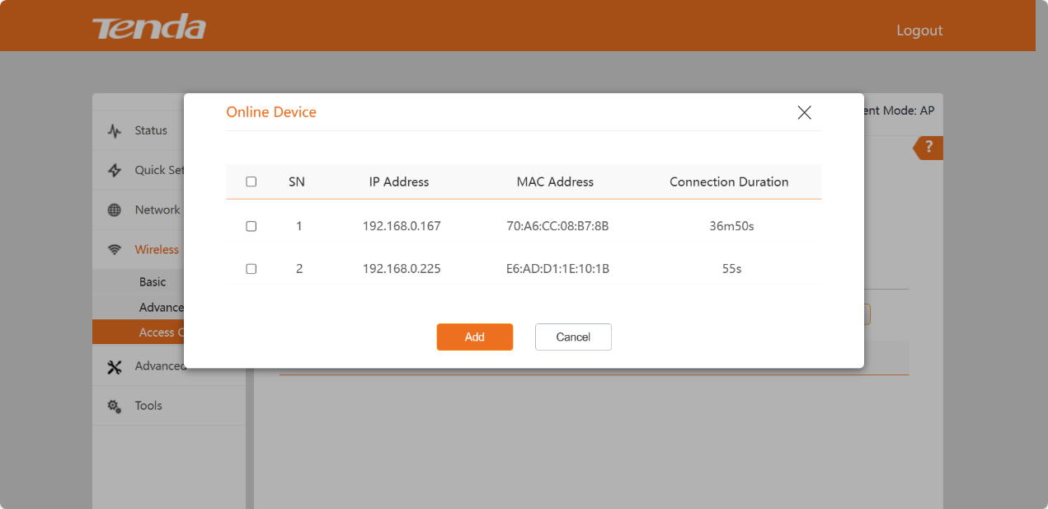

Step4： After add the device ,it will show in the page,and we can change its Status to Enable,also can ddelete this device.

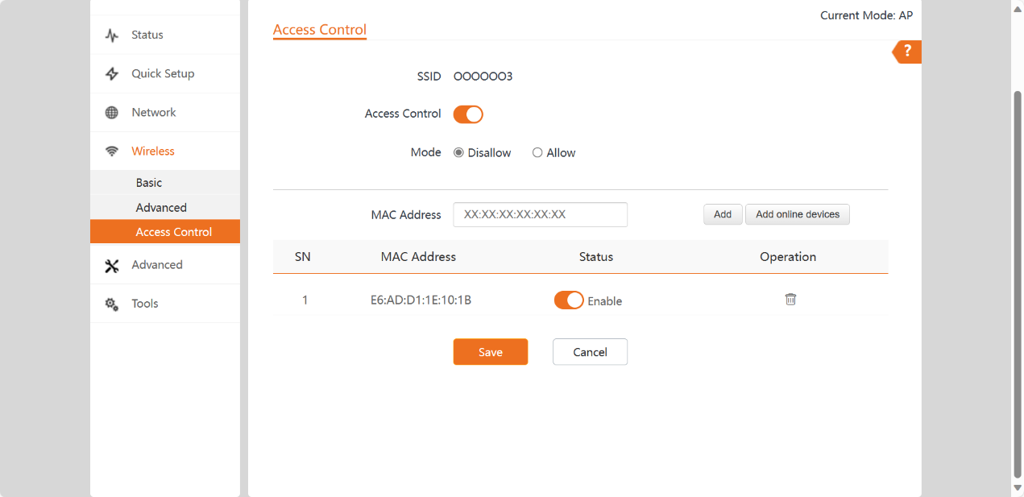

Step5：When we use Disallow Mode,our PC or phone cannot connect our network. This function can restrict strangers from connecting to our network.

