# What affects battery life?

This FAQ uses an Android phone as an example.

Note 1: When MF3 is connected to multiple devices, the traffic consumption will increase. At the same time, the power consumption of the device will also increase, and the power will be consumed faster.

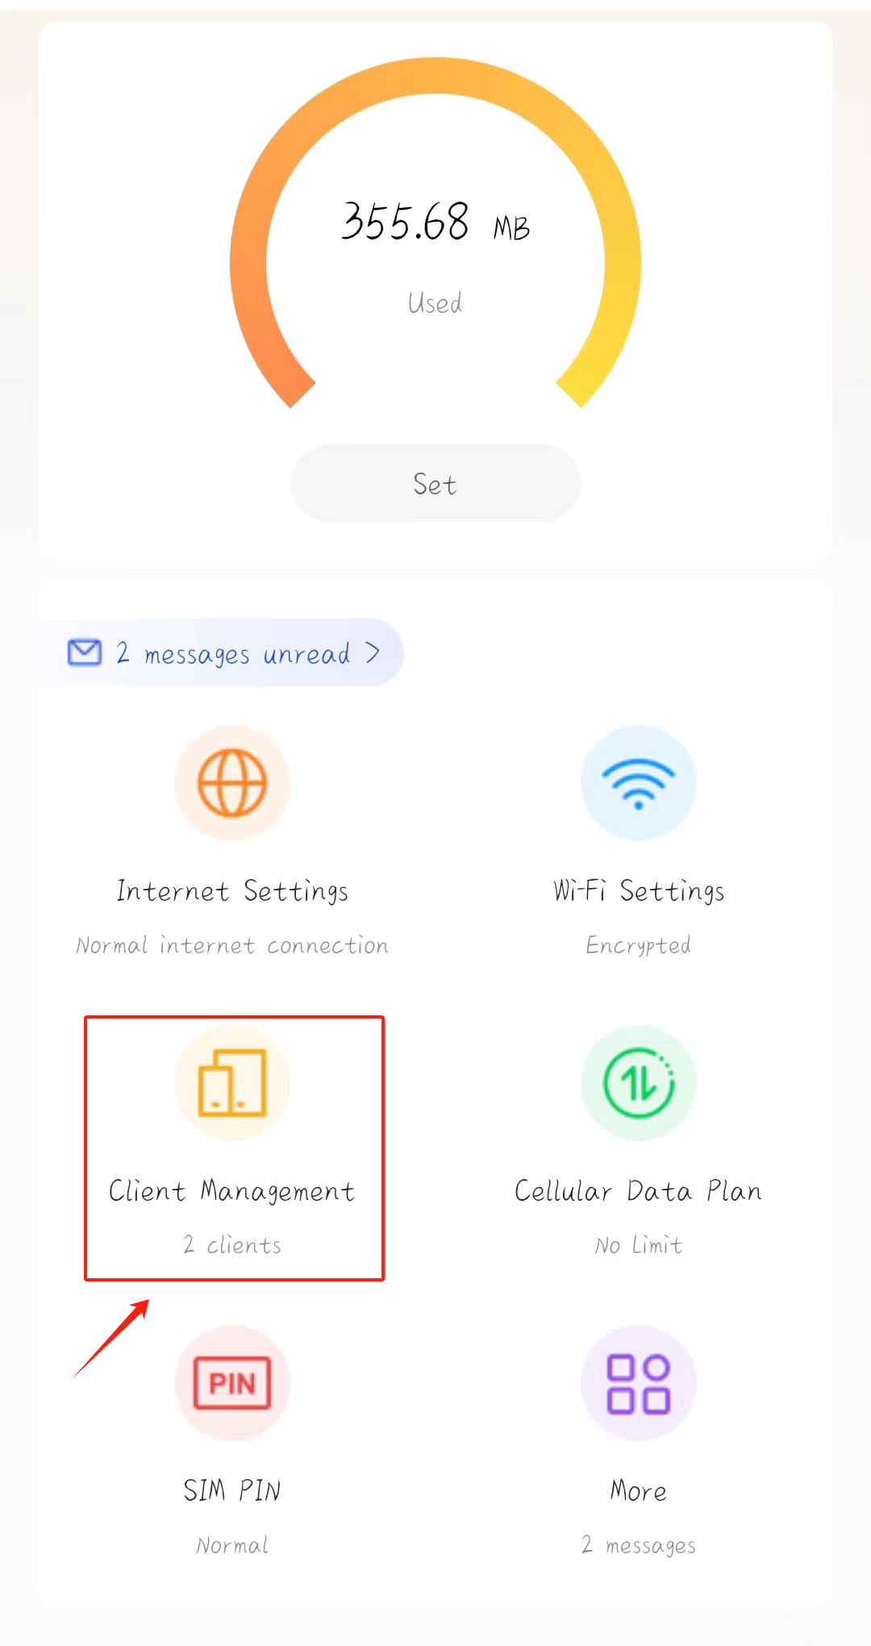

Note 2: Battery life is related to the local network signal. The weaker the signal, the greater the power consumption required to improve performance.

Note 3. Turn on power saving mode to get more battery life.

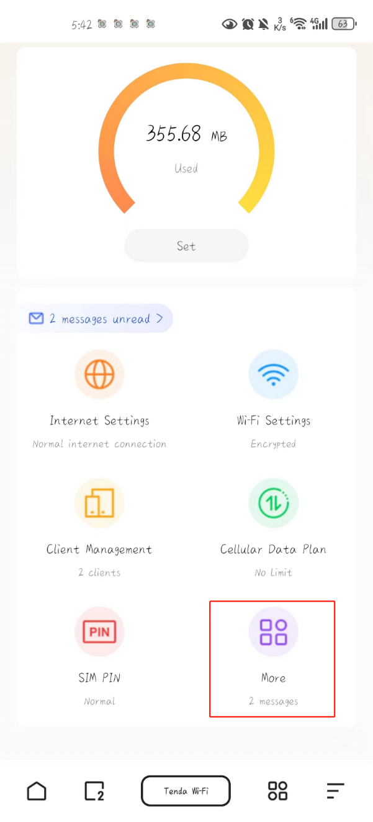

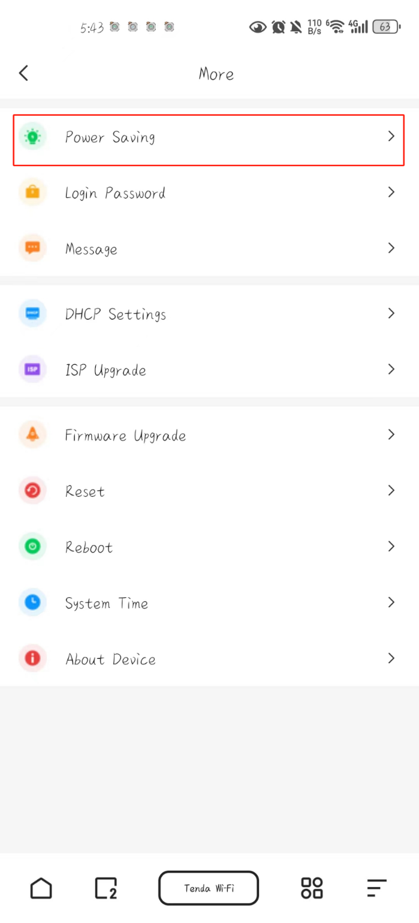

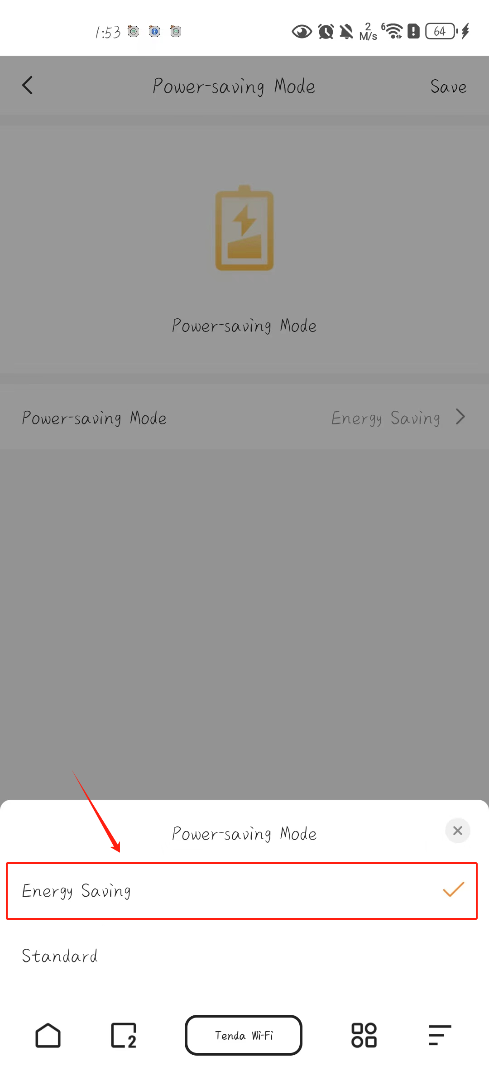

Note 4. Avoid overcharging, which may lead to loss of battery life and reduce battery life.