## Mobile phone hotspots are more stable than MF3, and MF3 network speeds are lower than mobile phone network speeds

This FAQ uses an Android phone as an example.

Solution:

1. Install the WIFI MOHO APP to see if there are multiple interferences around the WiFi

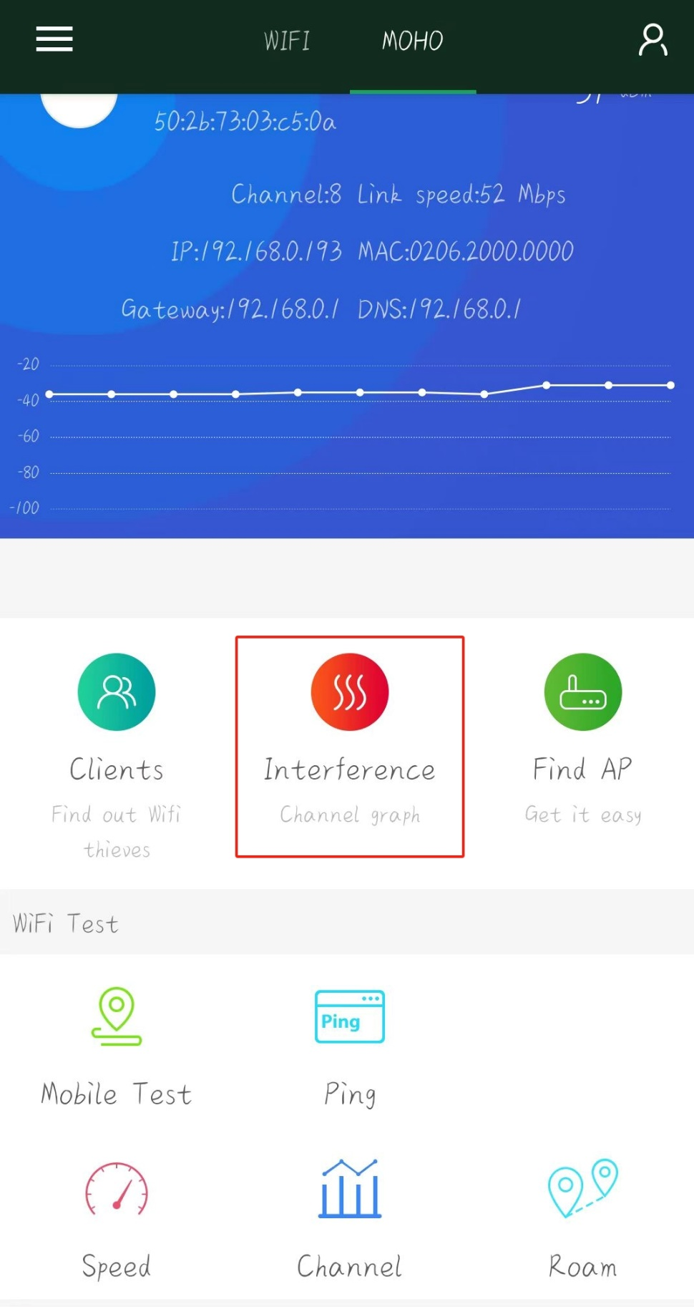

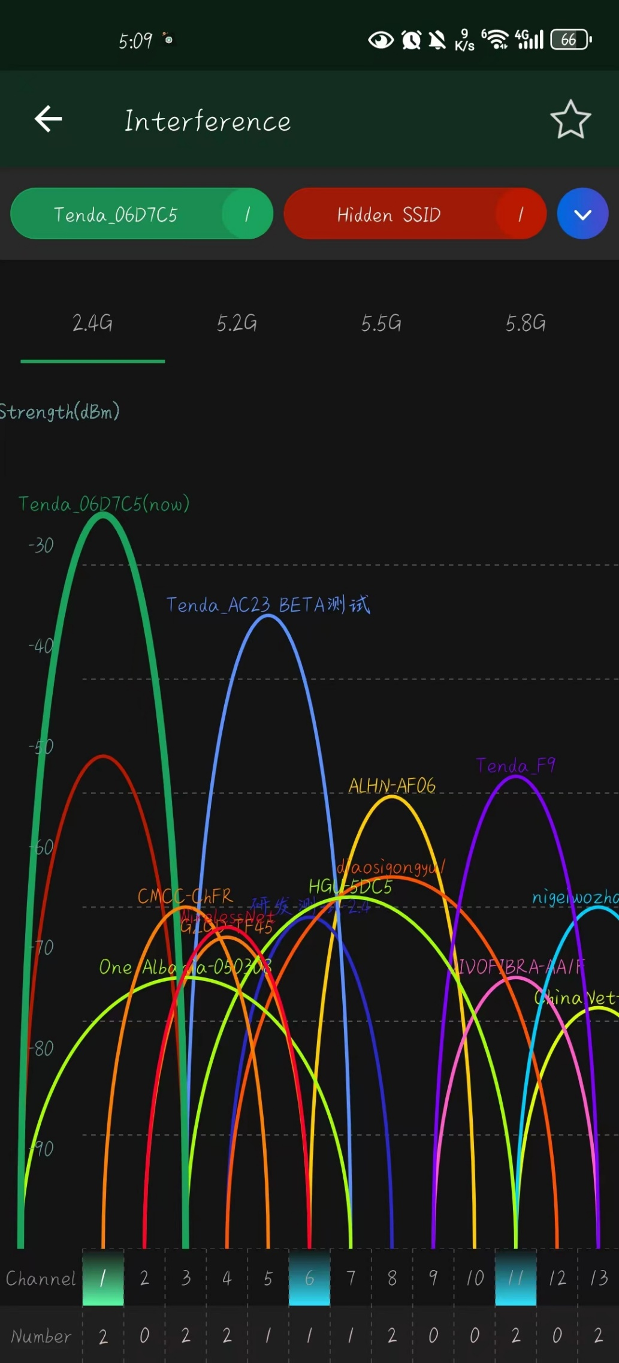

1. Enter the web management interface to confirm whether the device is in low battery. Low battery will cause WiFi performance to decrease.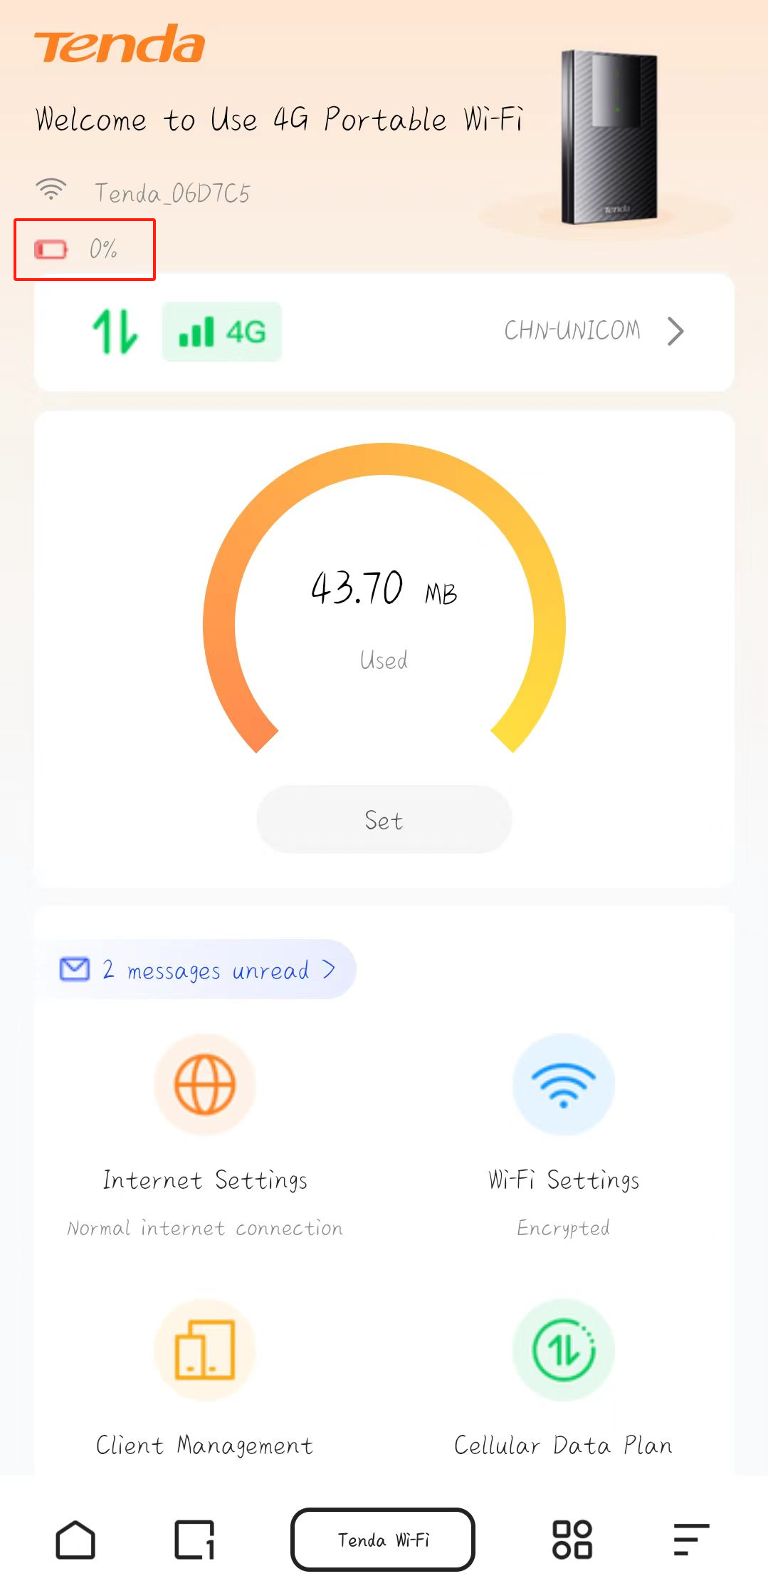
2. Log in to the web interface, confirm whether the power saving mode of the machine is set, and adjust the machine to standard mode.

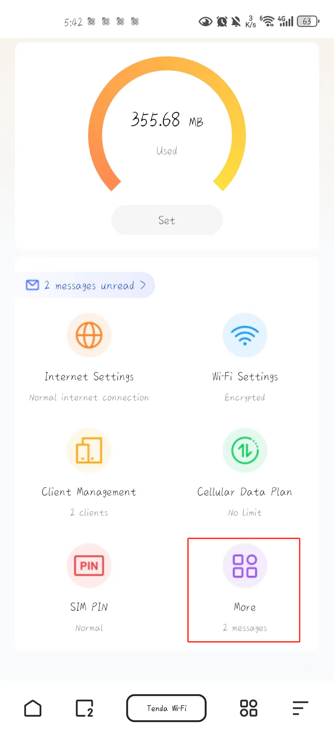

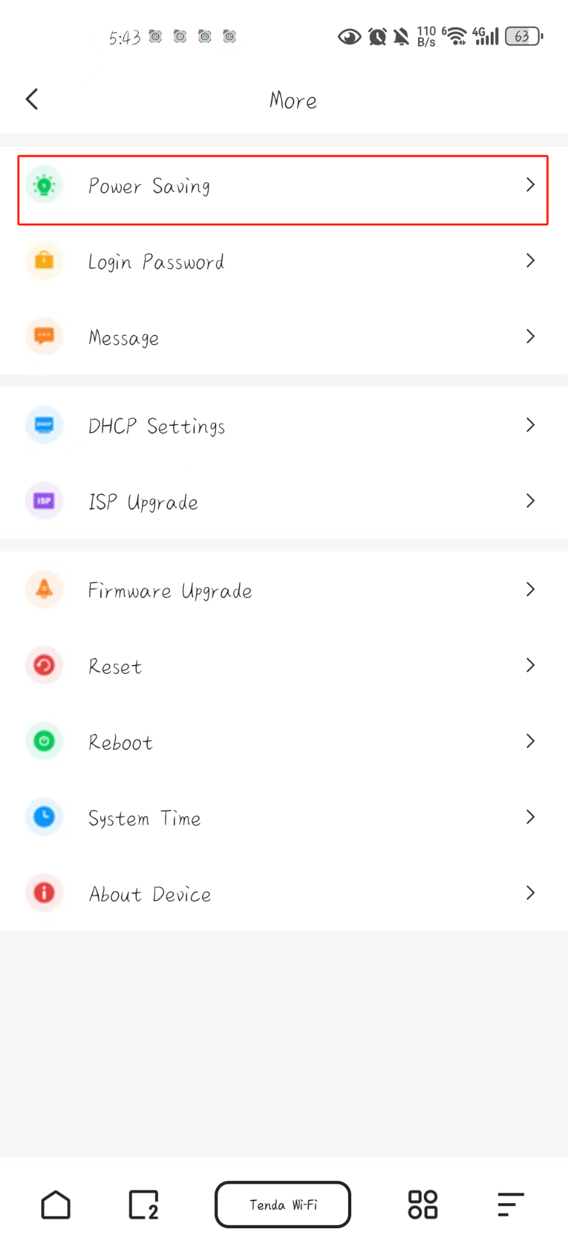

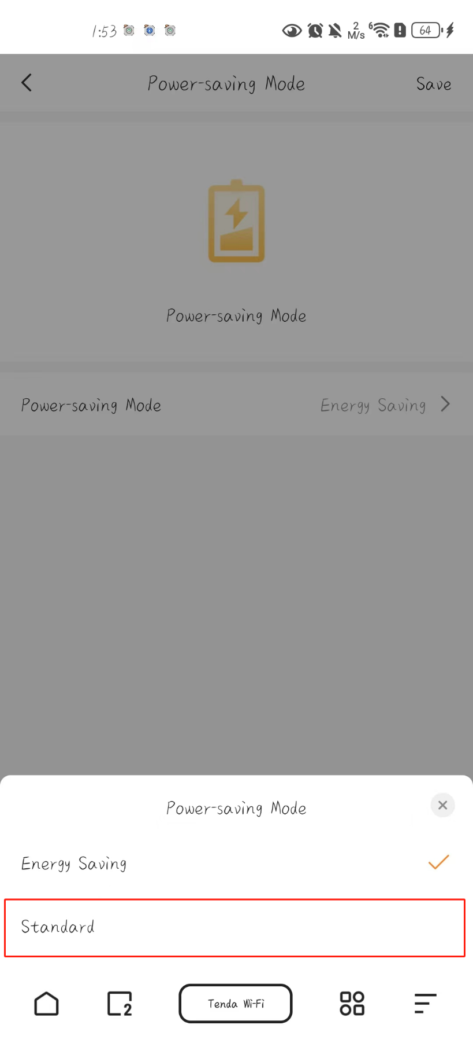

1. Log in to the web interface and confirm the number of machines on Client Management. Excessive number of machines will also cause performance degradation.

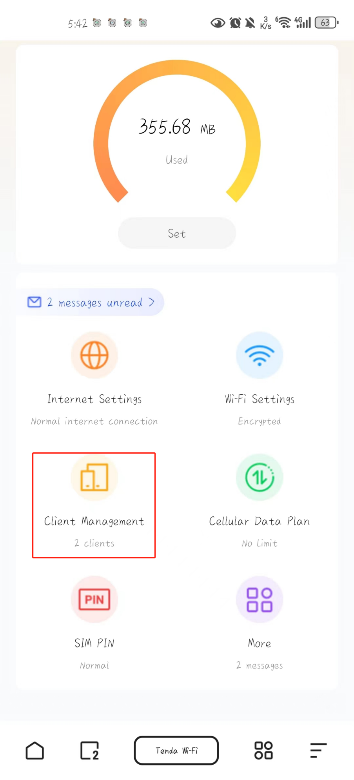

1. Reset/reboot the device to see if it is an instability problem caused by running for too long.

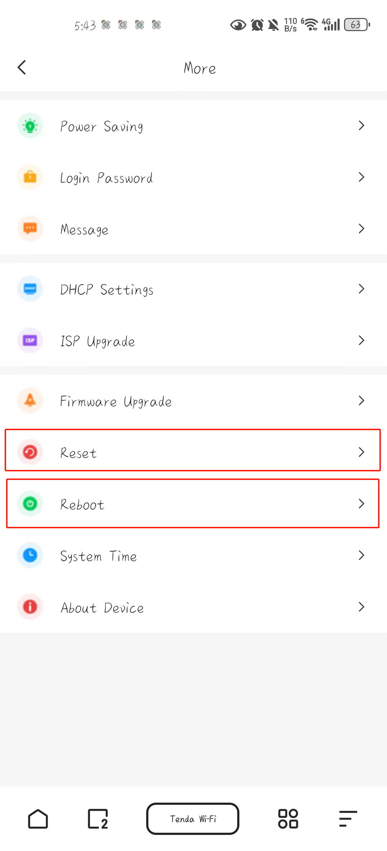

6. If your phone supports 4G+ and carrier aggregation, it will indeed be faster than our device.