# Device keeps losing signal and disconnecting

This FAQ uses an Android phone as an example.

Solution：1. Click the reboot button and try to restart the device to see if it returns to normal.

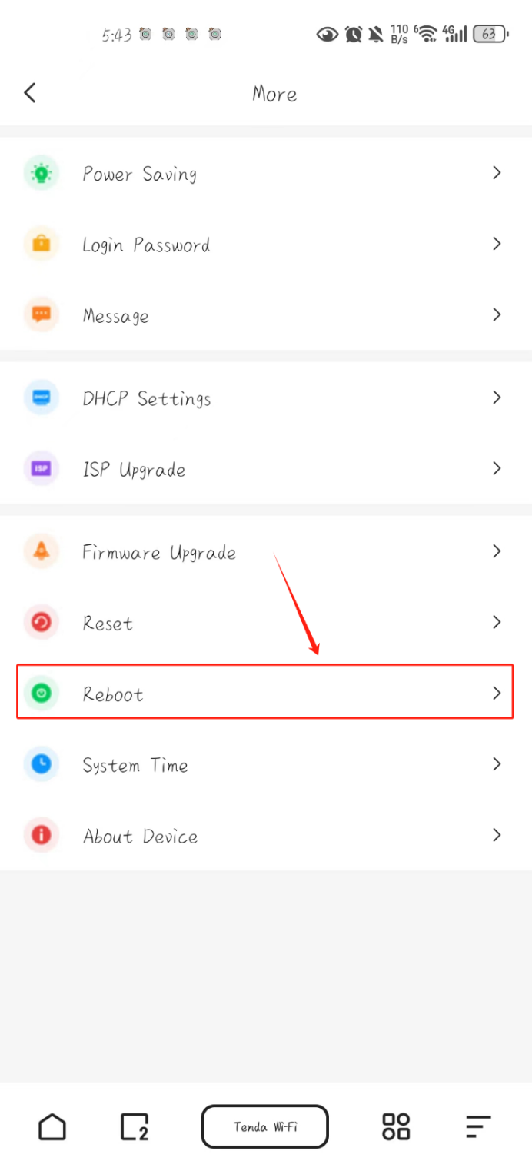

2. If rebooting doesn't work, try clicking the reset button to reset.

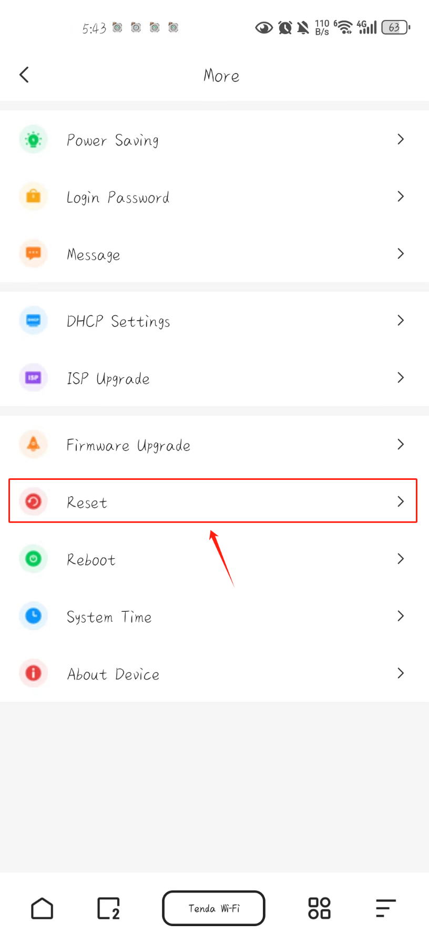

3. If you cannot log in to the WEB interface, please try a hard reset, keep the machine on, open the back cover, find the reset button, insert it with a needle and release the button after the power display turns orange and goes out.

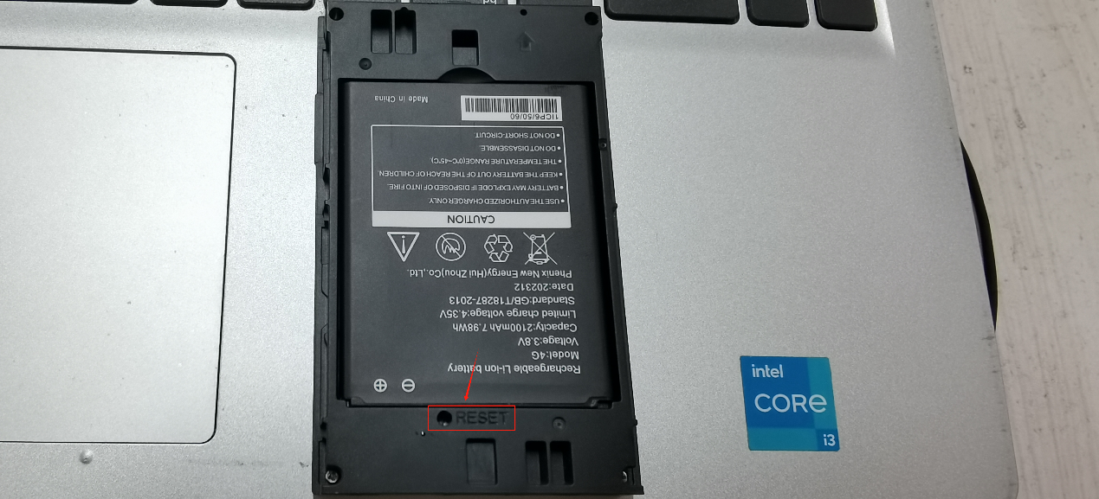

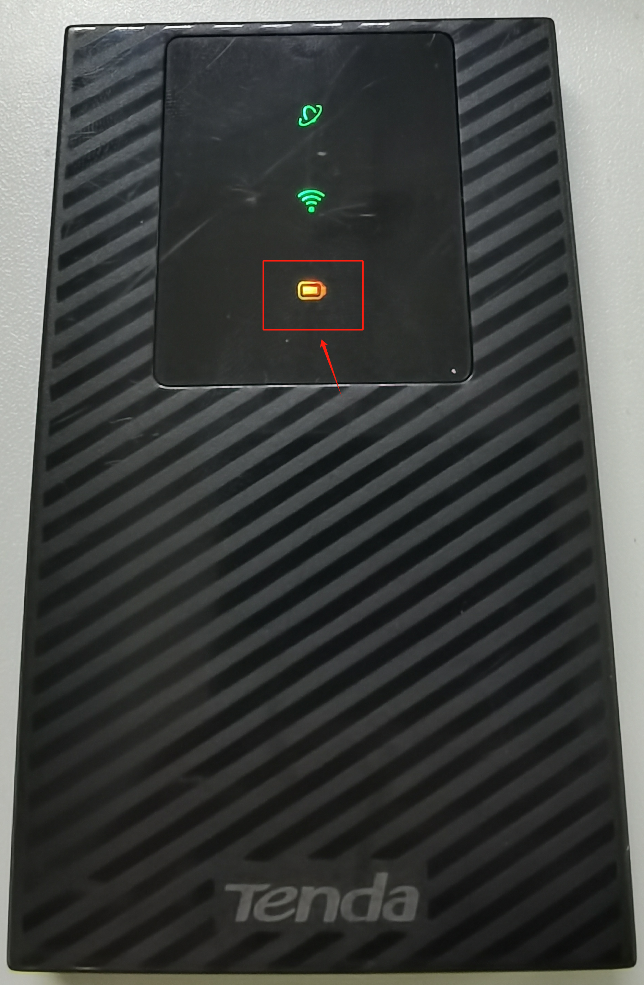

If it still cannot be solved, please contact our email [support@tenda.cn](mailto:support@tenda.cn)