**How to set up your router when using a DIGI SIM card**

Case: Dial-up failed using DIGI SIM card quick setup wizard page

Solution:

1. Remove your card and then you can skip quick setup wizard page.

Insert your SIM card again. Log in to the web page of the 4G LTE router, Click **Internet Status**, and check the Network status. You will see your Network status as shown below.

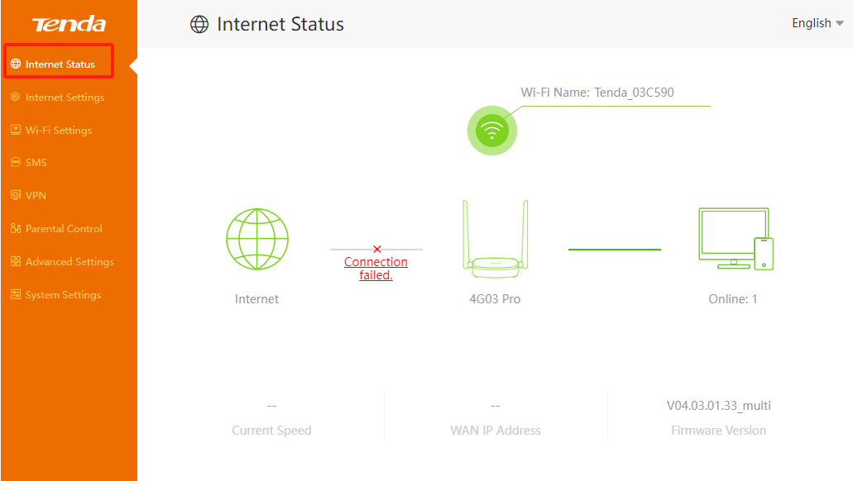

1. Turn on your **Data roaming.**

Click **Internet Setting** toturn on your **Data roaming.** And then click **Connect** and check your network status. You will be connected to the Internet.

