**How to set up as an add-on node of Tenda router?**

This section introduces how to add the router to an existing networking using the WPS button.

Please ensure that the router has never been used. If not, reset it first.

1 Place the router in an elevated and open position **within 3 meters** from your existing node.

2 Use the power adapter to connect the router to a power source, and wait until its LED indicator blinks **green slowly**.

3 Press the WPS button of the router for about **3 seconds**. The LED indicator blinks **green fast**. Within 2 minutes, press the MESH/WPS button of the node of the existing network for **3 seconds** to negotiate with this router. When the LED indicator of the router lights **solid green**, the networking is successful and the router becomes a secondary node in the network.

4 Relocate the secondary nodes to a **proper position**.

**TIP:**

⚫Ensure that the distance between any two nodes is **less than 10 meters**.

⚫ Keep your nodes away from electronics with strong interference, such as microwave ovens, induction cookers, and refrigerators.

⚫ Place the nodes in a high position with few obstacles.

5 Power on the secondary nodes again. Wait until these LED indicators blink **green slowly**.

6 Observe the LED indicators of the secondary nodes until the LED indicators light one of the following colors:

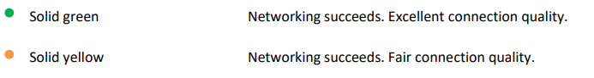

If any secondary node's LED indicator lights solid red, relocate it by repeating point **4** to **6**.

**Now you can access the internet with: •**

* **Wired devices:** Connect to the LAN ports of your nodes •
* **Wireless devices:** Connect to your Wi-Fi network using the Wi-Fi name and password you set (All nodes share the same Wi-Fi name and password.)