# **How to login to the Tenda Router's web management page when HTTPS is enabled？**

**1.Steps to login to the Router's web management page**

**a.** Connect your device to Tenda router.

**b.** Connect the device to the router via an Ethernet cable or wireless by using the SSID (network name) and password printed on the bottom label of the router.

**2. Access the web management page**

It's recommended to use Firefox, Chrome, Edge to access the web management page of router.

Type **[http://t](http://tplinkwifi.net/)endawifi.com** in the address bar, then press Enter.

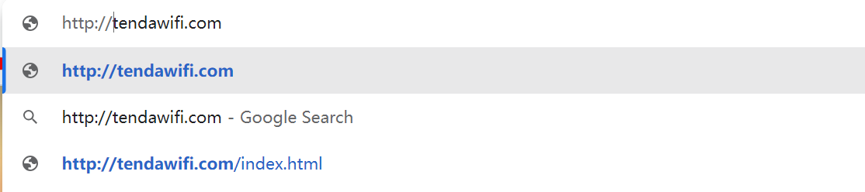

**3. Allow access to the Web GUI**

Click the '**Privacy error**' page.

Click on **Advanced ---- Proceed to tendawifi.com (unsafe)** Or **Advanced ---- Proceed to 192.168.0.1 (unsafe)**.

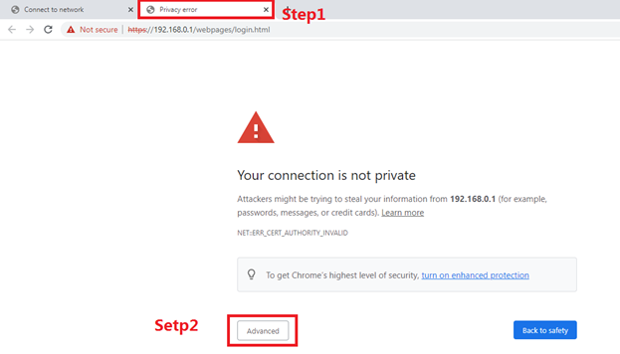

A warning message will show as below due to the browser requiring a signed certificate. Please don’t worry about that. The reason why browsers recognize tendawifi.com as “Not secure” is that tendawifi.com’s Certificate is a self-signed certificate. Most browsers will show this warning because tendawifi.com is not an authoritative CA. We can promise that the connection between your browser and the tendawifi.com server is secure.

**Note:** For more information about the self-signed certificate and unsecure notice, please refer to the FAQ here: [Why Tenda HTTPS web interface is detected as unsecure by some web browsers?](https://www.tp-link.com/support/faq/2598/)

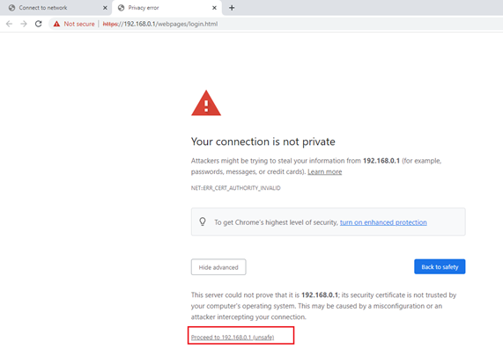

**4.set password for admin account**

Set a secure password for the administrator account as required

