**How to turn on/off the app notifications of CP3?**

1. Enter the TDSEE homepage and select the IPC you want to restart.

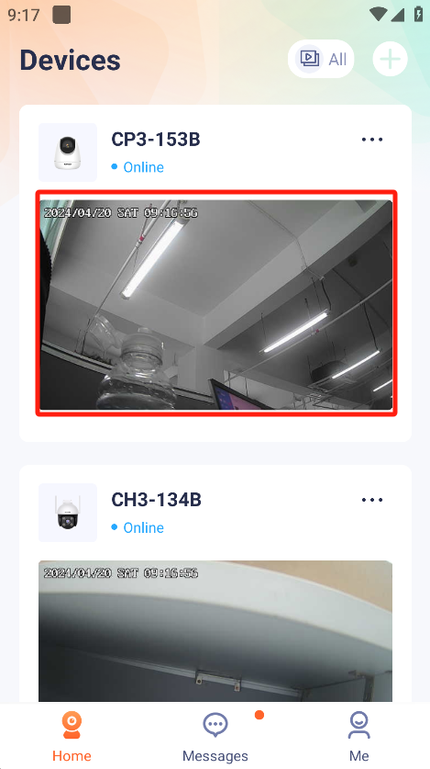

2.Press “Alarm”.Enter the alarm Interface.

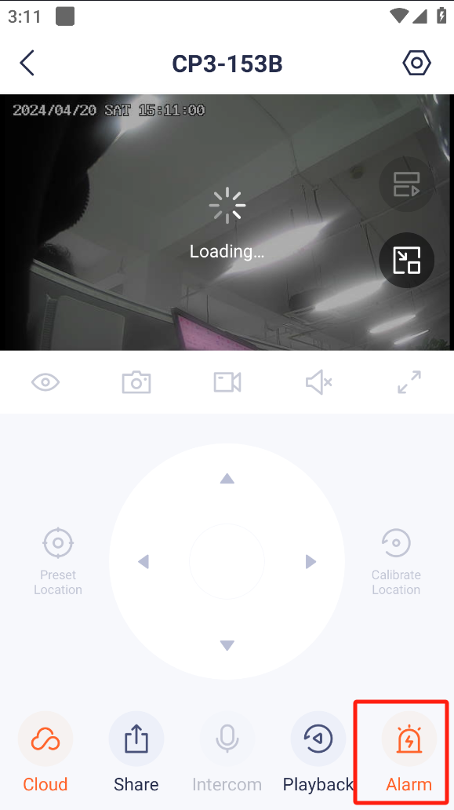

3.Press “APP Notifications” to turn on/off the APP Notifications.

