**How to switch the recording mode of CP3 Pro?**

1. Enter the TDSEE homepage and select the IPC you want to restart.

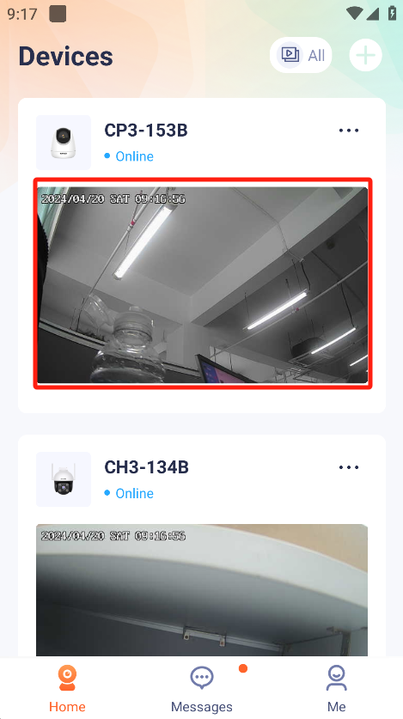

2.Press “Settings”.Enter the settings Interface.

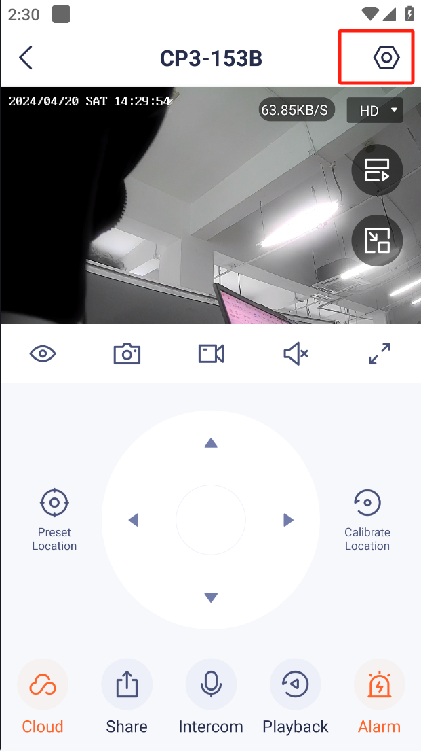

3.Press “Local Storage”

