**How to remotely control CR3 to restart?**

1. Enter the TDSEE homepage and select the IPC you want to restart.

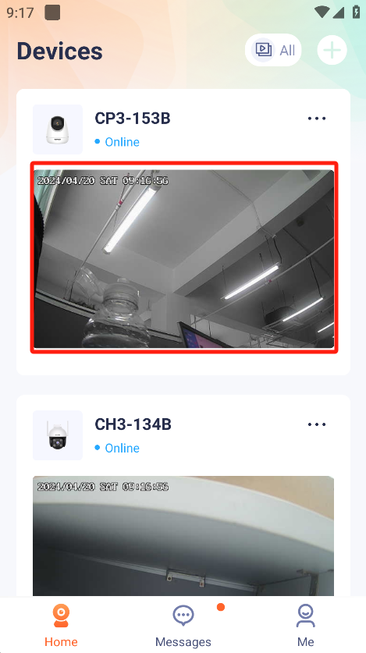

2.Press “Settings”.Enter the settings Interface.

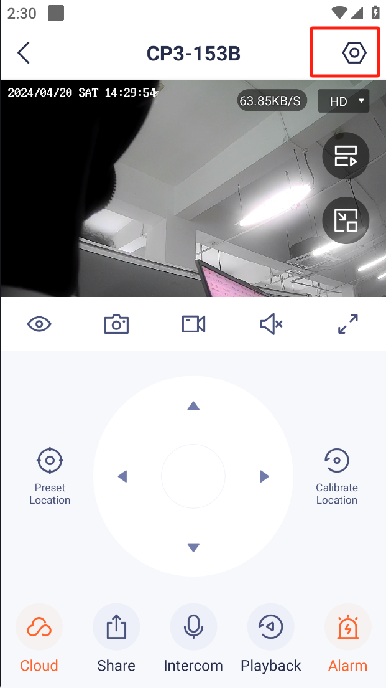

3.Press “More Settings”

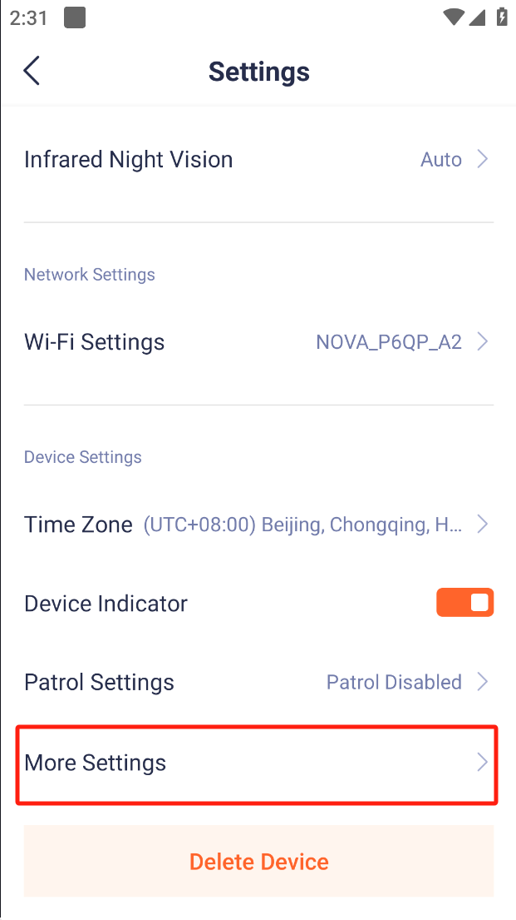

4.Press “Device Reboot”

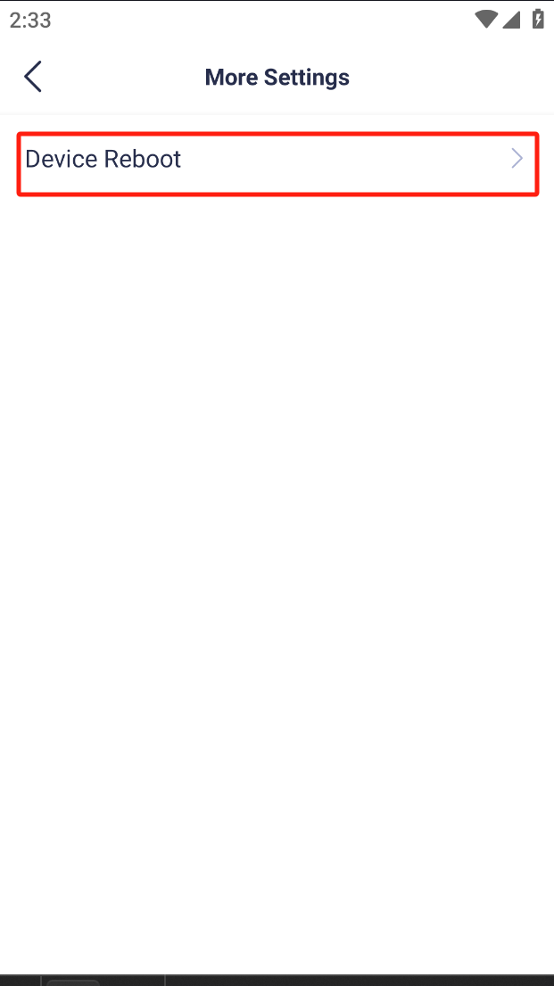

5.You can choose to restart immediately or schedule a restart.

