**What should I do when the video preview is not smooth?**

1. Check if the Wi-Fi network of the router is smooth.Take the router closer to the camera and adjust the antenna angle of the camera to be vertical.

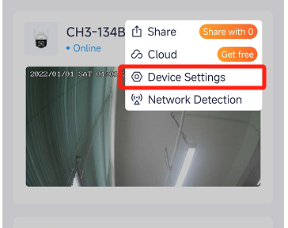

2.When previewing the video with cellular mobile data,make sure that the internet connection of the smartphone is smooth.

3.**Auto** (if supported),**Fluent** and **HD** are supported for video preview.You can switch the video clarity according to the internet status.

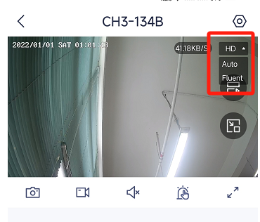

1. Check the signal quality of the camera.If signal is too weak,try to Improve network environment.

