How to troubleshoot if I have low speed with 4G LTE Router working as 3G 4G Router Mode

Internet speed can be affected by a variety of factors, such as LTE CAT type, 4G network, cellular base station connection band, Wi-Fi selection, etc. The manual FAQ will help you figure out what's causing the low rate and give you some tips to increase your speed.

Preparation:

Speed test comparison:

Before the speed test, please update your router's software to the latest version.

1. Connect your computer to your 4G LTE router via a network cable and test the router's wired speed.
2. Connect your computer or mobile phone to the Wi-Fi network of your 4G LTE router and test the wireless speed of your router.
3. Insert the same SIM card into another 4G router of the same category in the same location, and then test the wired and wireless speeds on the same client device

Note: Some users may use their phones to compare speed tests, but now most phones support higher LTE Cat types, such as Cat19 or Cat20, or even 5G, the higher the LTE type supported, the higher the speed that can be achieved, so it makes no sense to compare two devices that support different LTE categories.

Case 1: The speed of the LTE router is much slower than that of other routers of its kind

Solution:

**a.Maybe registered for a 3G network**

1. Log in to the web page of the 4G LTE router, go to **Internet Status**, and check the **Network status.**

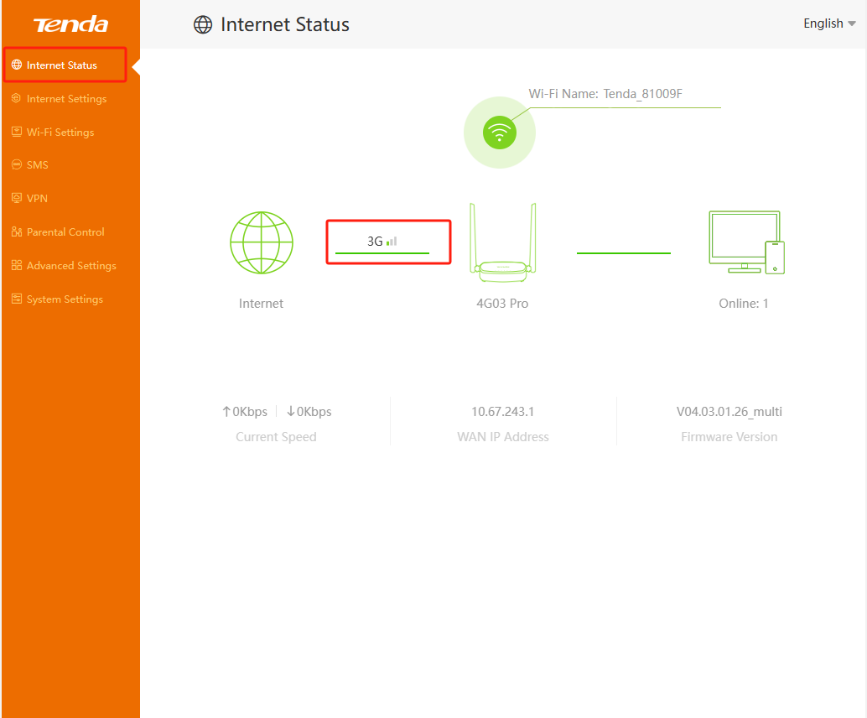

1. If the mobile network type is not 4G, please confirm whether your location is covered with 4G signal, if so, go to the **Internet Settings** page, change the **Mobile Data Options to 4G Only**, and save. Then wait for the router to connect to the network, check if the mobile network type is 4G

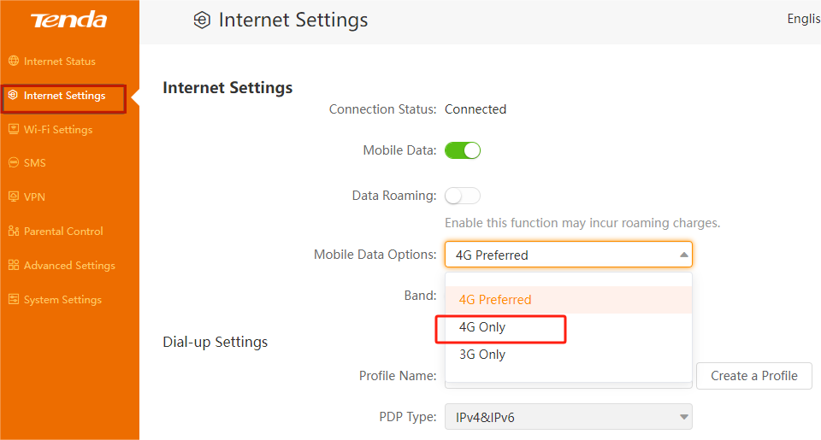

**b.Low speed caused by poor signal**

1. If your router is registered to 4G, but the signal light shows one bar，and the signal display on the **Internet Status** is also one grid.

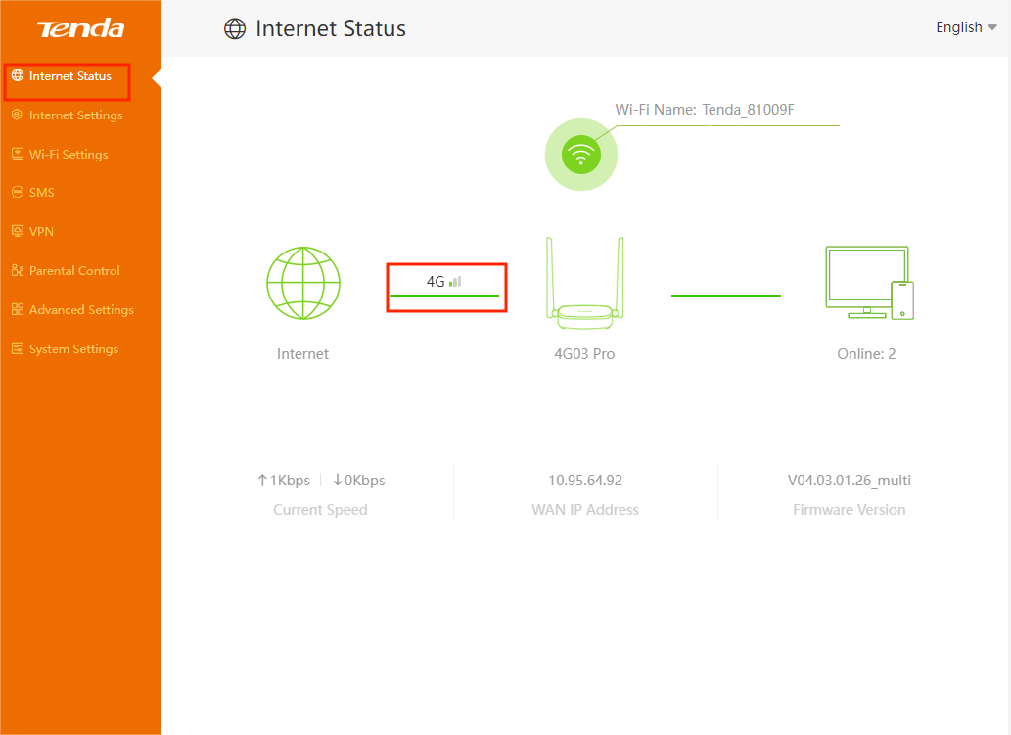

1. You need to move your location to find a place with better signal,check if the signal strength is good (Excellent or Good)

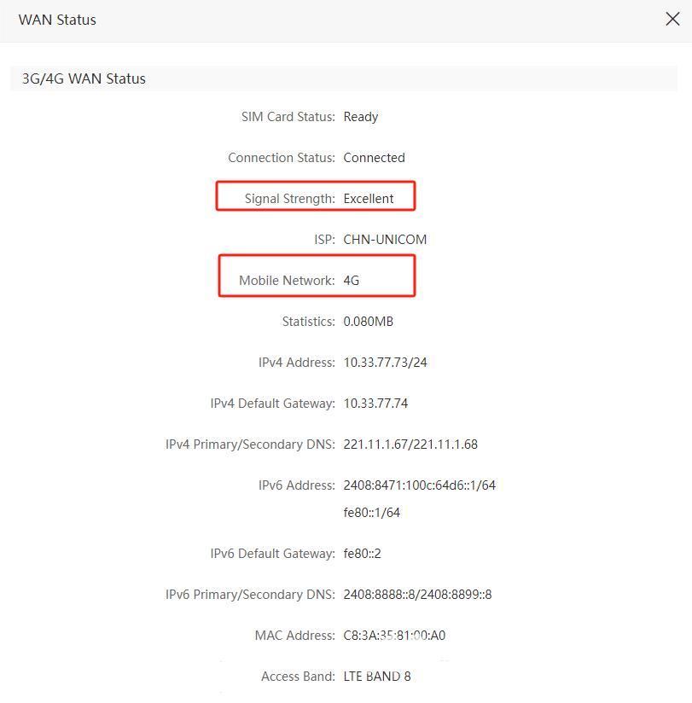

**c.Registered in the low-speed band**

1. If your 4G LTE router supports manual band selection, you can also try to select the bands supported by the SIM card one by one to find the best band in your area, and see if you can improve the speed after changing the band.

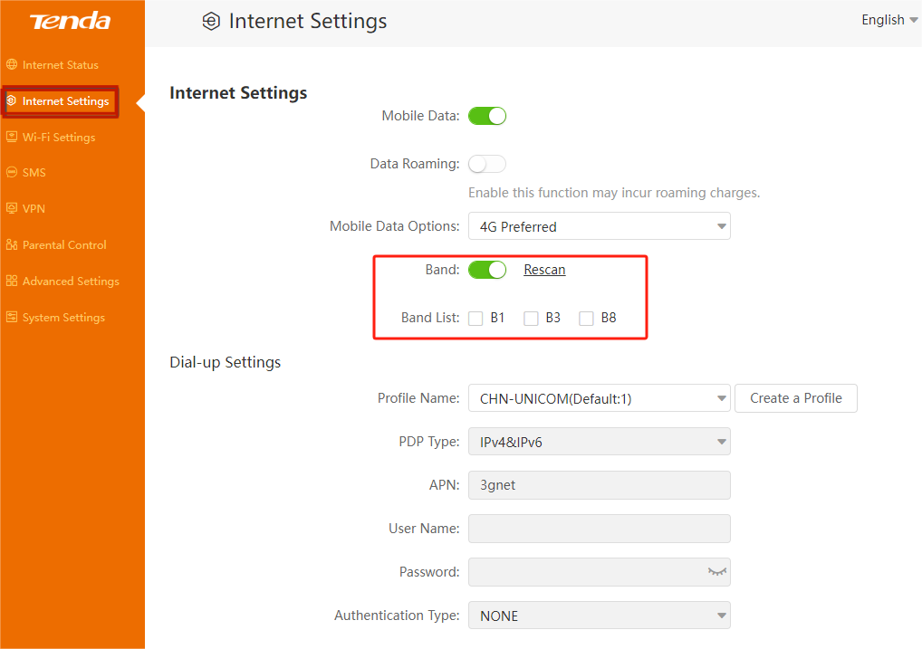

**d.Wrong APN network, resulting in poor speed**

1. If the router's wired speed is still slow, check if there are other **APN** profiles available, listed in the drop-down list of **Internet Settings->Profile Name**. You can also contact your SIM card carrier to see if they have other APN configurations, if so, try creating a profile on the **Internet Settings->Creat a Profile** page, connect to the network with this configuration, and check if there is an improvement in speed.

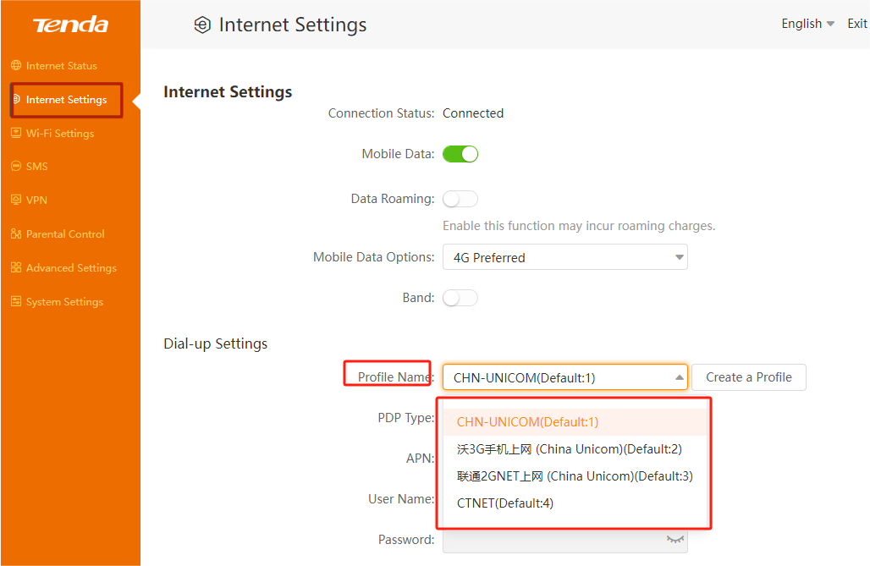

Case 2: The wireless speed of the LTE router is much lower than the wired speed

Solution:

1. Use only one terminal to wirelessly connect to the 4G LTE router, use the speed test website (www.speedtest.net) to test the speed three times, and record the speed test results (screenshot).
2. Check the wireless connection rate of the terminal device and record the result (screenshot).

Windows

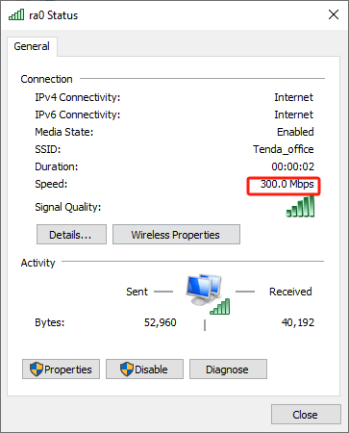

**a.Low bandwidth may be negotiated**

1. Change the wireless bandwidth from 2.4GHz to 40MHz. Test if the speed has improved after the modification.

**b. Interfering with large channels is not the best option**

1. Please confirm whether the slow speed is 2.4G wireless. For 2.4GHz wireless, try changing the wireless channel one by one to check if there is a speed increase (usually 1, 6, 11 channels are optimal, but any channel can be used).

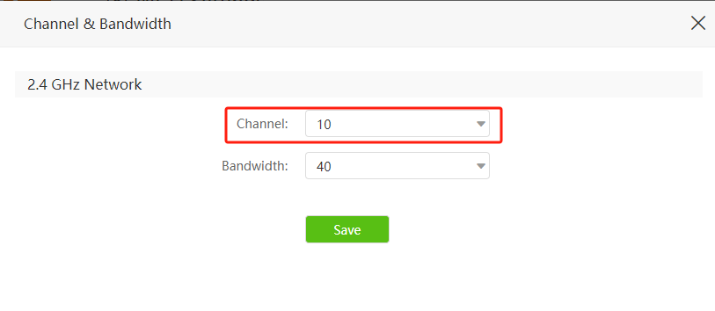

1. Try to place the router in an environment with less interference or an open environment.

If the above methods still do not solve your problem, you need to contact Tenda support to further solve your problem. You can contact **support.fwa@tenda.cn** with your **operation and test results**.

Get to know more details of each function and configuration please go to Download page to download the User manual of your product.