**No internet connection when using Tenda Wireless 4G LTE Router working as 3G/4G Router Mode(Situation 1)**

Note: This article is applied in the following situation: you can connect to the wireless of 4G03 Pro, but none of your devices can get internet access.

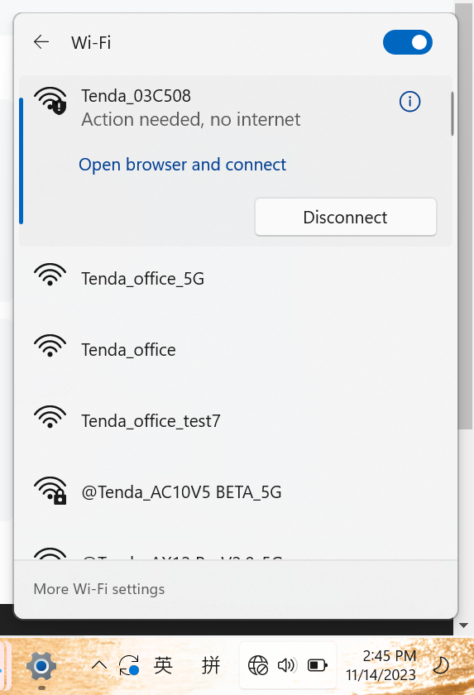ion: log in the web interface ----check the Ip address in the **Internet Status** page.

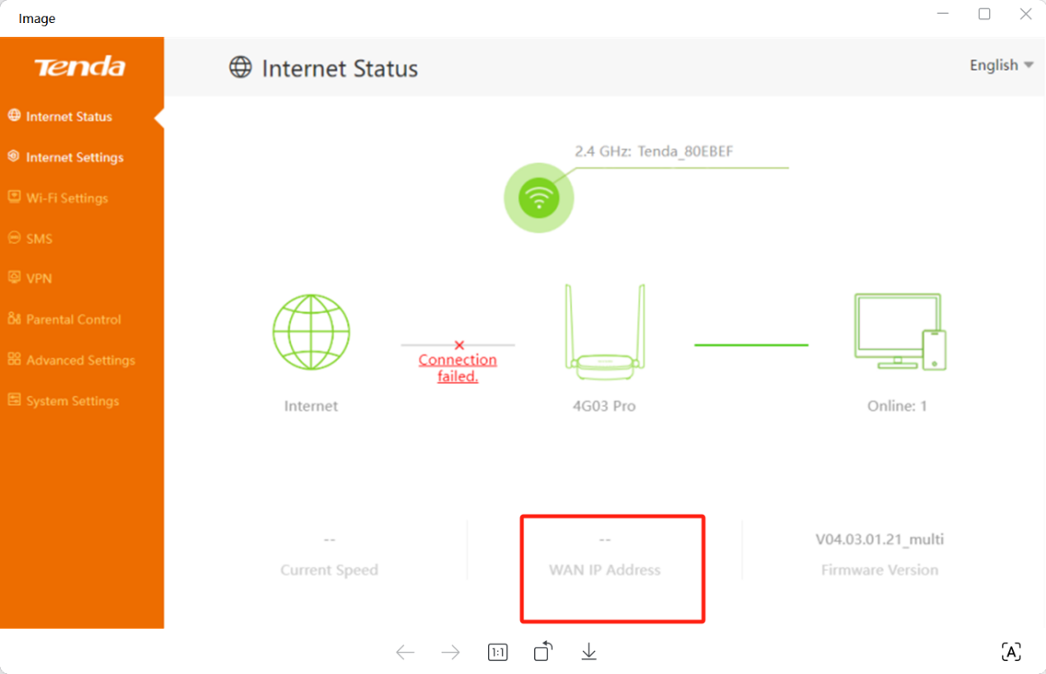

If the Ip address is not blank, then refer to this FAQ.

If the IP address is blank, it means the router is not connected to the internet yet. The reason can be that the SIM card’s supporting BAND is not the same as this router’s or the router’s pre-configured APN profile doesn’t match with your SIM card etc.

Solution

1: SIM card’s supporting band doesn’t match the router

The phenomenon can be that a SIM card has been detected but Network Type shows “**Connection failed**” on the **Internet Status** page.

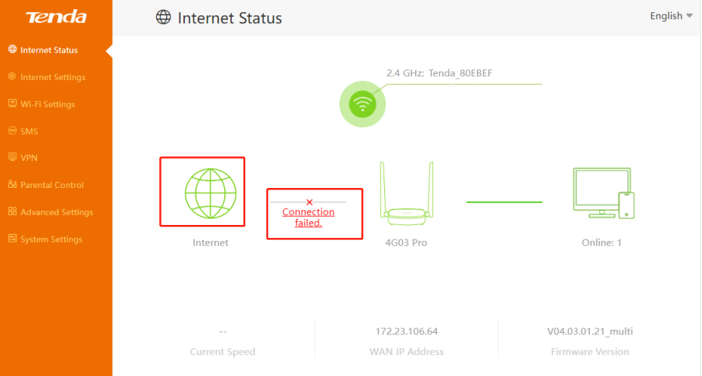

Solution: Make sure the SIM card itself works fine on another 4G router or your phone. Reset the router to factory defaults by holding the reset button for about 10s. If still the same, check with your SIM card carrier to confirm the Network Type and Band supported by the SIM card, then you may compare them with Network Type and Band supported by the 4G router displayed on our Official Web Site (Use 4G03 Pro as an example).

2. The SIM Card is locked by PIN code.

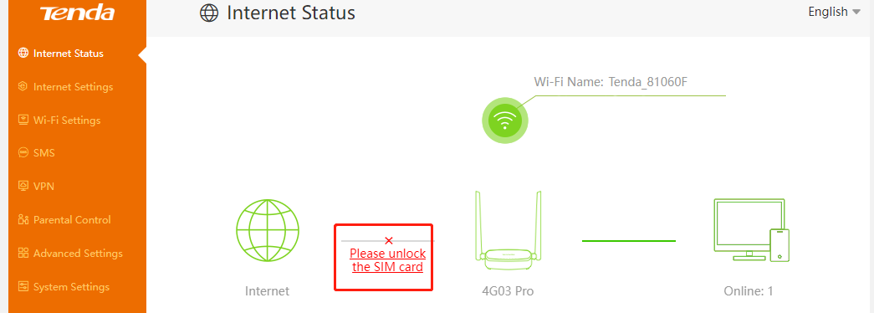

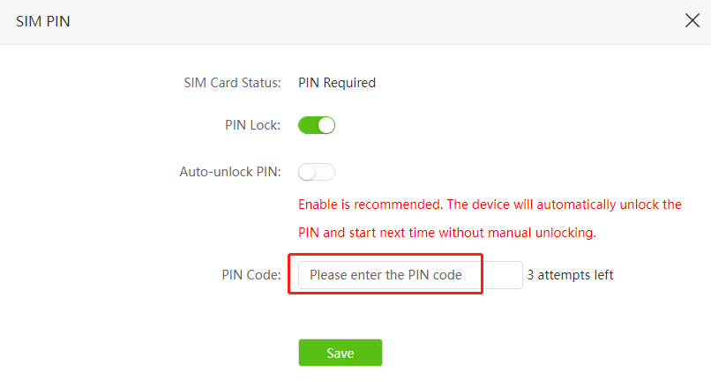

Solution: Enter the PIN code of your SIM card to unlock it, you have three chances of mistyping it, if you are not sure about it, contact your SIM card carrier to confirm it.

3: The router’s pre-configured APN profile doesn’t match with your SIM card

APN profile of known carriers are pre-configured in the router, but sometimes, your carrier may change their APN without our notice, or the carrier may have different APN profiles for different SIM card packages

Solution: Choose other available profiles in the Profile Name list or create a profile manually.

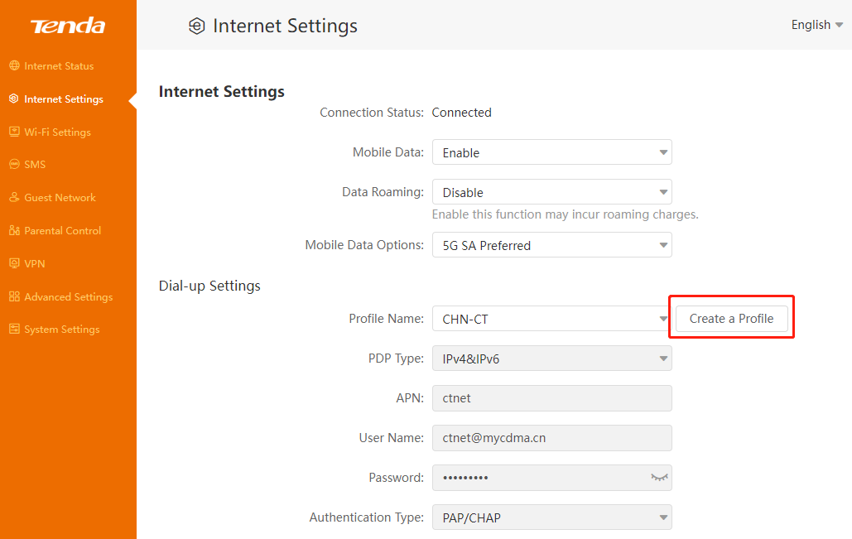

If there are no other available profiles, the following information will be needed to create a profile manually, if you are not sure about it, contact your SIM card carrier to confirm it:

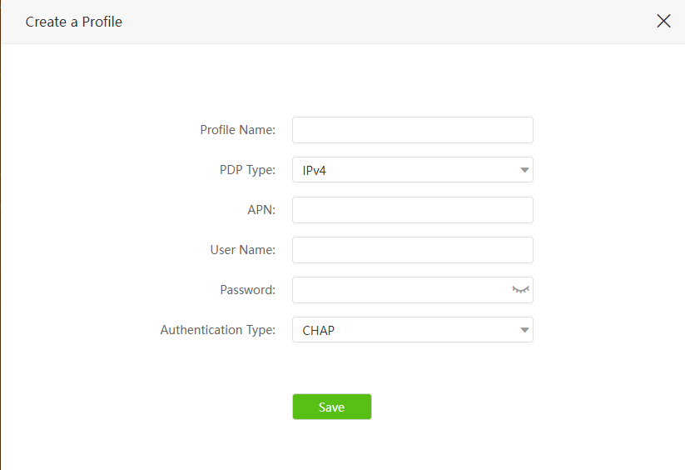

After you do the above troubleshooting, if still no internet access, you may update the firmware to the latest one for a try.

Get to know more details of each function and configuration please go to Download page to download the User manual of your product.