**No internet connection when using Tenda Wireless 4G LTE Router working as 3G/4G Router Mode(Situation 2)**

Note: This article is applied in the following situation: you can connect to the wireless of 4G03 Pro, but none of your devices can get internet access and you might see the following icon on your computer.

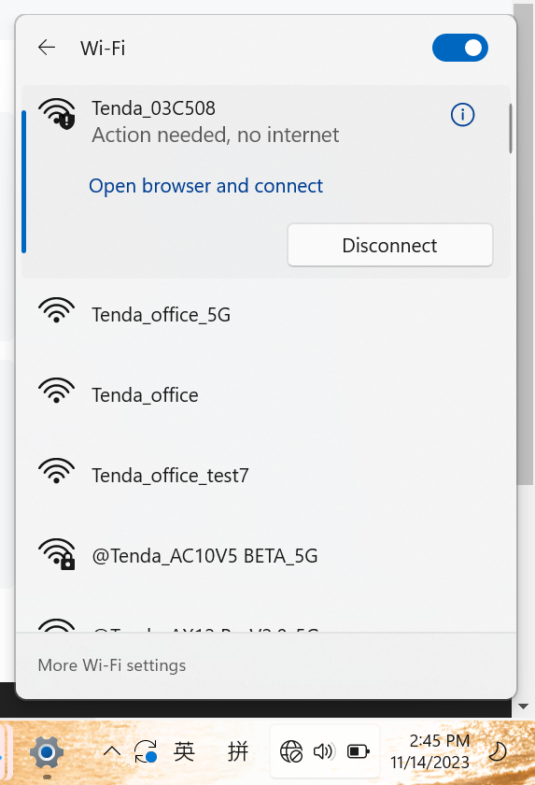

Preparation: log in the web interface ----check the Ip address in the **Internet Status** page.

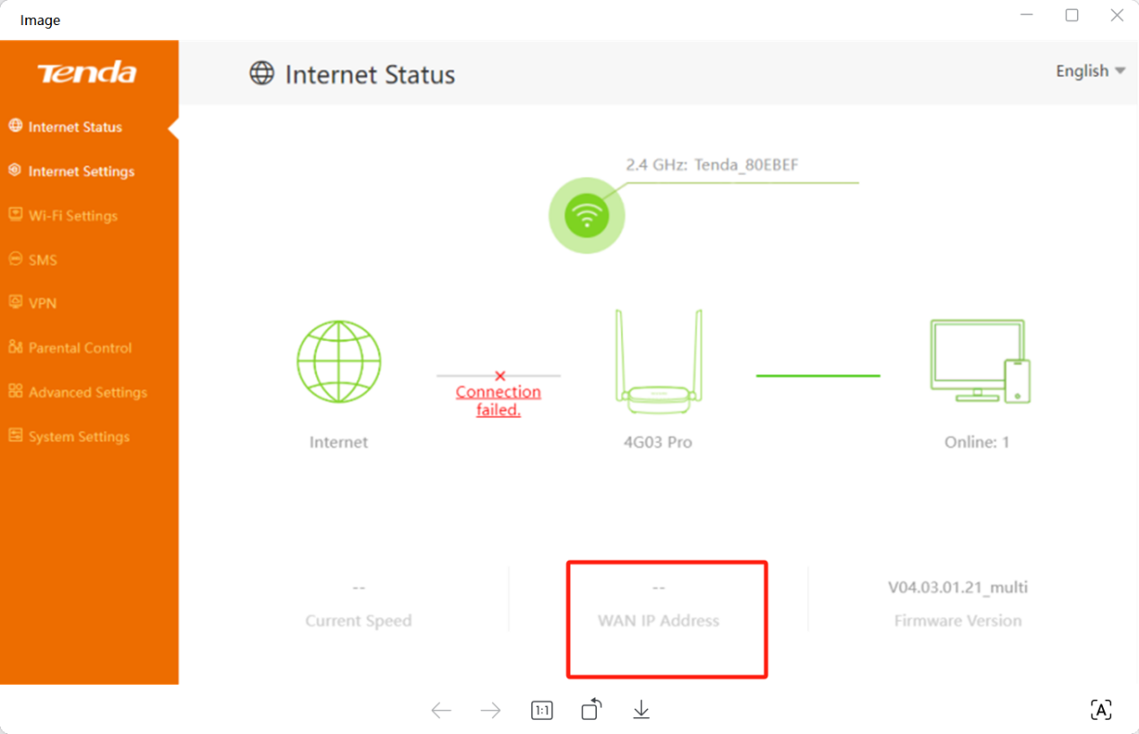

If the ip address is blank, please refer to this FAQ.

If the IP address is not blank, then the reason you don’t have internet access may be DNS, unstable 3G/4G network etc. Please refer to the following instruction to do troubleshooting.

Solution

1: Unstable 3G/4G network.

Solution: make sure that the SIM card is working properly when it’s inserted in your phone at the same place.

2: DNS problem.

Sometimes, the default DNS server assigned by the SIM card carrier might not work due to some unclear reasons.

Solution: go to System Settings->LAN Settings, change “**Primary DNS**” to “**192.168.0.1**”, change the “**Secondary DNS**” to “8.8.8.8”, then save it.

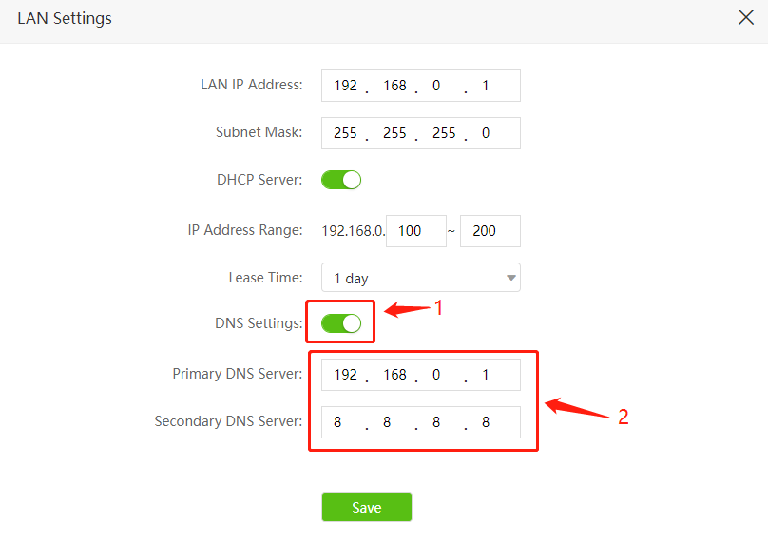

After you do the above troubleshooting, if still no internet access, you may update the firmware to the latest one for a try.

Get to know more details of each function and configuration please go to Download page to download the User manual of your product.